November 2, 2021
Email: endionspei@gmail.com Website: nspeidiocese.ca/den
Facebook: Environment Network Diocese of NS & PEI
Welcome to our weekly Enews.
The Diocesan Environment Network (DEN) of the Anglican Diocese of NS & PEI, was formed in response to the Fifth Mark of Mission and the latest addition to our Baptismal Covenant which has become our Mission Statement.
“To strive to safeguard the integrity of creation and sustain and renew the life of the earth.”
To do this we educate and encourage stewardship through social media and liturgies, connect with other environment groups, pray together, celebrate art with each other and grieve together.



Thursday Night DEN Gatherings – November 4 th @ 7pm via Zoom - Hope & Inspiration Art Gallery. Meet some of the artists. The Hope & Inspiration Art Gallery began as an online Art Show when we could not mount a physical exhibit. It featured 4 local artists from the Environment Network of the Anglican Diocese of NS & PEI. Dale Cook, Luke Haugen-Strand and Wendy Bissett Beaver are painters with their own unique styles and Donna Giles is a Nature Photographer.
Art expresses ideas that words cannot and projects dreams we cannot accomplish in other ways. In all its forms, art can remind us of the beauty in the world. Recognizing that the climate crisis is the most significant crisis of our time, art can inspire us to reconsider our relationship with creation and point the way to a different, more sustainable world. It is our hope the art will reconnect you with the beauty of the earth. We invite you to allow the art to inspire you to face the climate crisis and vow to take better care of our world.
Praying with the DEN Community Each Friday at 9:30 we host Morning Prayer live streamed on Zoom. Prayers take shape from different traditions and focus on various aspects of our relationship with Creation. To obtain the link, please email endionspei@gmail.com
Please Join us for a DEN BOOK STUDY & DISCUSSION GROUP
STARTING TOMORROW
JULIEN OF NORWICH:
WISDOM IN A TIME OF PANDEMIC…AND BEYOND
BY MATTHEW FOX
Wednesdays at noon, 1200 – 100 pm, November 3 to December 15 via Zoom
Hosted by STELLA LORD IN COLLABORATION WITH LIZ GALSWORTHY AND BRUCE LANGHUS
To be added to the book study mailing list contact the registrar: brucelanghus@gmail.com

THE DEN BOOK STUDY FORMAT  Each week we will read a chapter of Fox’s book and come prepared to discuss or raise questions, provide our insights. and otherwise engage with Fox’s book.  As the title suggests, Fox’s book is an exploration of Julien’s Revelations of Divine Love but also a reflection or commentary on her theological insights as these relate to the sadness and death associated with the contemporary issues related to the COVID-19 pandemic, climate change, and other environmental and social challenges. However, you might also find it helpful to refer to Julien’s original reflections on her visions which she called “showings”. This is available in several modern translations, but Fox relies primarily on Mirabai Starr’s, Showings of Julien of Norwich: A New Translation. Starr wrote the foreword to this book and his book is also available in print form as well as on Kindle.  Key questions to reflect upon will be sent to participants ahead of each gathering. These will inform our discussions but we aim for participation so please do not let these questions limit your thinking or your reflections, or any comments you want to make as we discuss each chapter. | 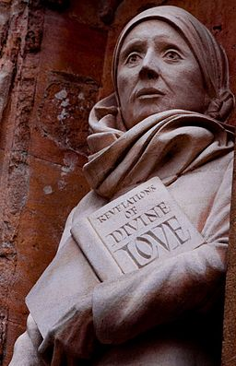  Statue of Julian of Norwich, Norwich Cathedral, by David Holgate FSDC  Image reproduced under creative commons. https://creativecommons.org/licenses/by-sa/2.0/deed.en  More information about the book study, contact: StellaLord8@gmail.com


Green Cent$
November 18-20, 2021
A ZOOM Symposium
sponsored by the Diocesan Environment Network (DEN)
Diocese of Nova Scotia and Prince Edward Island

Green Cent$ is about people, liturgical practices, building and site management.
Green Cent$ is for ALL church people - those who already have experience in greening their church, as well as those who feel they have a lot to learn.
Green Cent$ is for people of all ages and all talents. There is a role for everyone in greening our churches. We are all in this together.

Join us on: Thursday, Nov.18th, 7:00 PM, to hear Bishop Sandra Fyfe and
Saturday afternoon, Nov. 20th to hear Archbishop Mark MacDonald

Thursday, Nov. 18, 7:00 – 9:00 Friday, Nov. 19, 7:00 - 9:00
Being Green Spiritually Practical Aspects of Parishes
The Nuts & Bolts of Being Green Achieving Greenness

Saturday, Nov. 20, 10:00 - 12:15 Saturday, Nov. 20, 1:15 - 3:00
Green Church Case Studies: Funding Part 2- Anglican Foundation
A Covenant to be Green Concurrent Workshops:
After Doing Green Audit Multi-use of Church Facilities UK Eco Church Program Caring for People
Funding Part 1- Diocesan Grants Green Advocacy
TBA
Closing - Love of Creation

Registration Deadline: November 15th
To register: (Activate 1 and 2 to register for all of symposium OR 1 or 2 to register for part.)
- Thursday and/or Friday: https://us06web.zoom.us/meeting/register/tZEpd-GvqzsoHtPoQlhtwCZdahB9ir1r9c14
- Saturday: https://us06web.zoom.us/meeting/register/tZEscumrqjwrHt2CYjNb1xTNU4o-LrZvf1eh
After registering, the program and confirmation Email with the link to join the ZOOM event will be sent.
For more information Email: endionspei@gmail.com Or Call: 902-483-6866
GREEN CENT$ Becoming green is a matter of SENSE as well as CENT$

UN Climate Change Conference – Programme of Events from the COP26 Green Zone. https://ukcop26.org/the-conference/green-zone-programme-of-events/?mc_cid=a84d0a5ea2&mc_eid=8928db02a

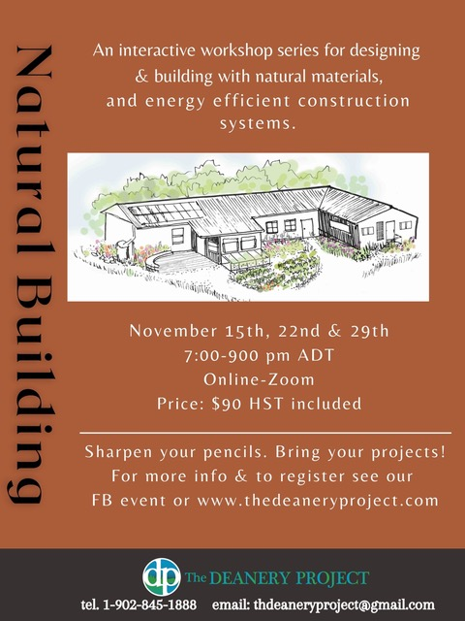
This live-streamed, participatory series looks at a wide range of systems and materials used in natural buildings, and is grounded in permaculture design principals. Participants will receive an introduction to major elements of natural building design and construction, and have opportunities to share questions about projects they may be working on. The journey begins with where to site a building, and moves through wall systems, roof and foundation options, and natural finishes.
The program is a mix of lecture and experiential learning. Each week there will be out-of-class work to practice ideas being explored in-class. At the end of the series students will understand: what to look for in siting a building; heating, cooling and energy options; pros/cons and characteristics of different natural materials for wall, roof and foundation systems.
Space is limited. Please call Charles should you have any questions. (902) 829-2264, or the Deanery 902-845-1888

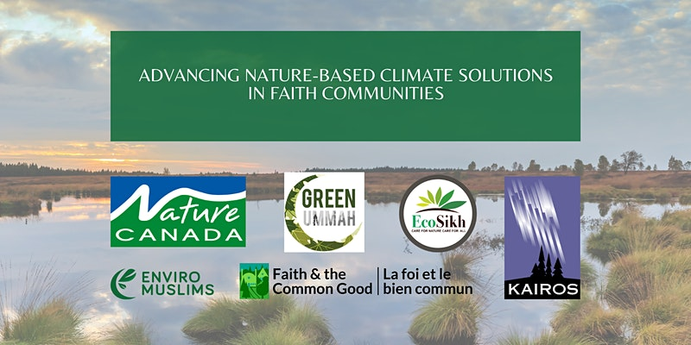
Join Nature Canada, Indigenous and faith leaders for a conversation on Nature-based Climate Solutions!
We would like to invite you to this interactive Zoom gathering on Tuesday, November 16 from 6:30-9:00 pm EDT, to build knowledge and capacity for action by faith-based communities on nature-based climate solutions.
For more information and to register:
https://www.eventbrite.ca/e/advancing-nature-based-climate-solutions-in-faith-communities-tickets-183527464587

Letter from Greta to World Leaders re Emergency

Letter from Greta Thurnberg and three other young people to world leaders at COP26 "Millions will suffer as our planet is devastated -- a terrifying future that will be created, or avoided, by the decisions you make. You have the power to decide. As citizens across the planet,we urge you to face up to the climate emergency. Not next year. Not next month. Now:
Keep the precious goal of 1.5°C alive with immediate, drastic, annual emission reductions unlike anything the world has ever seen.
End all fossil fuel investments, subsidies, and new projects immediately, and stop new exploration and extraction.
End creative carbon accounting by publishing total emissions for all consumption indices, supply chains, international aviation and shipping, and the burning of biomass.
Deliver the $100bn promised to the most vulnerable countries, with additional funds for climate disasters.
Enact climate policies that protect workers and the most vulnerable, and reduce all forms of inequality.
Letters to key cabinet ministers

Last Tuesday Prime Minister Trudeau unveiled his cabinet. But with so much going on as they return to Parliament, ministers will only speak up if they think it’s what the public wants. If thousands of us flood key ministers' inboxes with emails — as Trudeau is at the most important global climate summit, COP26, we would be impossible to ignore. Note you will need to change the prepared email to read that Trudeau is at COP, not on his way.
Petition to stop acceleration of Ocean Acidification

Under the Canada Shipping Act, ships are allowed to use “scrubbers,” a device that turns ship exhaust fumes into wastewater so ships can cheat clean fuel standards and continue to burn the fossil fuel from the bottom of the barrel. The result? Ships dump BILLIONS of litres of carcinogenic wash water that can be up to 125,000 times more acidic than the surface of the ocean. Billions of people around the world depend on a thriving ocean for food, to support their livelihood, and to keep the planet’s ecosystems healthy.
Petition on the Just Transition Act
Let's make sure the Canadian government gets to work right away on climate action that protects people and the planet. Join 350.org to send a clear message to Canada's federal party leaders that we need a justice-centered transition off fossil fuels.
Petition against Thermal Coal
Council of Canadians chapters and supporters have helped to deliver a series of crushing setbacks to the expansion of metallurgical (steel-making) coal mining in Alberta. Now, we need to build on that momentum – and we need your support. To move Canada beyond coal altogether, we must work to put an immediate end to thermal coal production and exports. Thermal coal, used to generate electricity, is the world's largest source of greenhouse gas emissions. And while the government has committed to ending our domestic dependence on coal-powered electricity by 2030, Canada continues to export millions of tonnes of both Canadian and American coal. As long as these exports continue, Canada will be an emissions enabler – not the international climate leader it claims to be.

Green Story –this and that
Grandma doesn’t like to praise a “product” until she has tried it herself. Any products I show a picture of on someone’s website is not asking you to buy. It is just to show you what is out there to use. I came across so many ideas and products that this will be a this and that week again.
There is a product called a Plant Nanny that I do know about. They are square shape stakes that hold a wine bottle upside down.
You can use wine bottles and stick the necks straight in the ground and they slowly leak out. So why buy a Plant Nanny? Dirt gets in when you push the bottle in the ground. Dirt can clog water flow and sort of make a bottle useless. Then there is the job of washing the bottles between waterings. Plant Nannies keep the bottles clean. Fill them up and turn them upside down inside a Plant Nanny. It is best if you have 2 wine bottles for every plant nanny. Then you can just exchange bottles.
https://www.youtube.com/watch?v=AtFsKGA9tM8
There are watering spikes. I used these this summer with a one litre water bottle. They kept everything growing in my containers so well
https://www.leevalley.com/en-ca/shop/garden/water-and-irrigation/soakers/62806-deep-root-watering-spikes?item=AK202&utm_source=free_google_shopping&utm_medium=organic&utm_campaign=shopping_feed&gclid=Cj0KCQjwlOmLBhCHARIsAGiJg7lGO7-kmF1V8nFjMQTGEpMfcGav37xi0m_cNyKSmMj0yIewjVSiIhQaAidEEALw_wcB
I miss my garden, but this is the time to get things ready for next year. I came across this article on making our own DIY soaker hose. Considering that I was going to throw out an old hose “sometime”, this was perfect timing. Grandma prints out the article, tucks it in a sheet protector, tapes the top shut and ties it to the old hose. Maybe it won’t get done before the snow flies, but everything will be in one place when time allows. See how it is done here.
https://www.thespruce.com/how-to-make-a-soaker-hose-1388583
Anyone who knows me knows I love wind turbines. I see small wind turbines and water energy as a way to give electricity anywhere. I think I may have found the perfect way to do that but that is not ready yet. The more we research, the more we learn. I found this article on how to make wind turbines, all different types.
https://thumbwind.com/2020/07/21/diy-renewable-energy-projects/
Instructables even has a tutorial on wind turbines
https://www.instructables.com/How-I-built-an-electricity-producing-wind-turbine/
Popular mechanics has an example
https://www.popularmechanics.com/science/environment/how-to/g118/make-your-own-miniature-wind-turbine/
Craft - Sailboat
Our craft this week is a sailboat. Some days are too cold for the little ones to go play outdoor for too long. Life can get boring. A sink half full of water and a few boats can make for a great play time
You will need
A sponge
A stick or other upright to hold the sail
A square piece of solid material for the sail (paper, boxboard, styrofoam, etc)
Tape, stickers, markers, crayons to decorate the sail
I am thinking of a sponge approximately 3 x 5 or 4 x 6 inches. I usually buy the type of sponge used for scrubbing pans and reuse them after the grandbabies leave for dishes washing. Use what you may have around the house or buy the cheapest ones you can.
Your bow or front of the boat needs a pointy end. The stern or back of the boat stays the same.
Make your sail and decorate it.
Make an opening in the sponge to hold your mast. I cut two slits in the sail and push the mast through the sail, wedging it upright on the sponge.
Here is the beginning of many a sea battle or getting products to market or having a vacation by boat. There are so many stories to be made up while sailing your boat around a sink. Have fun.
Something to eat - ONE LOAF Bread
Making bread is usually a day long process. It is an easy thing to do but a person need to be around the house.
This bread you can start when you start a full cooked meal like a meat, potatoes veggie dinner. It makes just ONE loaf of bread,
In a bowl put 1 cup warm water, a teaspoon of yeast or half an envelope of yeast and some sweetener (sugar, honey, etc.) Add a tsp or two of oil and a dash of salt,
Add about 2 cups of flour until the dough is stiff. Set bowl aside the best part of an hour while you peel veggies etc.
Punch down the dough, put it in your pan and let rise another half an hour.
Put it in the oven about half an hour till the bread sounds hollow.
Fresh hot bread for a meal
It will be heavy and crusty but Oh so good!
Now I am hungry. I must make one. Until next week, Grandma is sending hugs
With thanks to Elizabeth Huether for the use of her prayers and slides from last week’s Friday Prayer time.

