October 19, 2021
Email: endionspei@gmail.com Website: nspeidiocese.ca/den
Facebook: Environment Network Diocese of NS & PEI
Welcome to our weekly Enews.
The Diocesan Environment Network (DEN) of the Anglican Diocese of NS & PEI, was formed in response to the Fifth Mark of Mission and the latest addition to our Baptismal Covenant which has become our Mission Statement.
“To strive to safeguard the integrity of creation and sustain and renew the life of the earth.”
To do this we educate and encourage stewardship through social media and liturgies, connect with other environment groups, pray together, celebrate art with each other and grieve together.



Thursday Night DEN Gatherings – October 21st @ 7pm via Zoom – Nova Scotia Environmental Network with Chris White

Please Join us for a DEN BOOK STUDY & DISCUSSION GROUP

JULIEN OF NORWICH:
WISDOM IN A TIME OF PANDEMIC…AND BEYOND
BY MATTHEW FOX
Wednesdays at noon, 1200 – 100 pm, November 3 to December 15 via Zoom
Hosted by STELLA LORD IN COLLABORATION WITH LIZ GALSWORTHY AND BRUCE LANGHUS
To be added to the book study mailing list contact the registrar: brucelanghus@gmail.com

THE DEN BOOK STUDY FORMAT  Each week we will read a chapter of Fox’s book and come prepared to discuss or raise questions, provide our insights. and otherwise engage with Fox’s book.  As the title suggests, Fox’s book is an exploration of Julien’s Revelations of Divine Love but also a reflection or commentary on her theological insights as these relate to the sadness and death associated with the contemporary issues related to the COVID-19 pandemic, climate change, and other environmental and social challenges. However, you might also find it helpful to refer to Julien’s original reflections on her visions which she called “showings”. This is available in several modern translations, but Fox relies primarily on Mirabai Starr’s, Showings of Julien of Norwich: A New Translation. Starr wrote the foreword to this book and his book is also available in print form as well as on Kindle.  Key questions to reflect upon will be sent to participants ahead of each gathering. These will inform our discussions but we aim for participation so please do not let these questions limit your thinking or your reflections, or any comments you want to make as we discuss each chapter. | 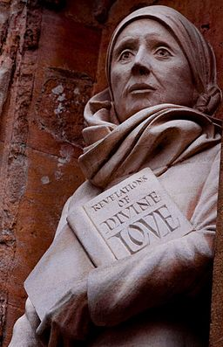  Statue of Julian of Norwich, Norwich Cathedral, by David Holgate FSDC  Image reproduced under creative commons. https://creativecommons.org/licenses/by-sa/2.0/deed.en  More information about the book study, contact: StellaLord8@gmail.com


Green Cent$
November 18-20, 2021. Save the dates!
____________________________________________________
A ZOOM Symposium sponsored by the Diocesan Environment Network, Diocese of Nova Scotia and PEI - The DEN. Join us on Thursday, November 18th, 7:00 PM, as we gather to hear our first speaker, Bishop Sandra.

Green Cent$ is about people, liturgical practices, building and site management. It is for all church people - those who already have experience in greening their church, as well as those who feel they have a lot to learn. It is for people of all ages and all talents. There is a role for everyone in greening our churches - we are all in this together.

We will look at:
Why we want to green our churches.
How to do it.
Where to find funding.
Sessions will be presented Thursday and Friday 7pm to 9 pm and
Saturday 10-12am and 1-3pm.

We are inviting speakers at this time.
If your church has a greening program already, why not share what you have accomplished during the Green Cent$ Program Case Study Session. Please Contact: endionspei@gmail.com

Diocesan Environment Network, Diocese of Nova Scotia and PEI - The DEN. 14/9/21
Dr. Margaret Bateman Ellison, GREEN CENT$ Zoom Symposium Coordinator

School Strike for Climate October 22. Students are planning another strike/rally/march this Friday, Oct 22 at 12:30 in Halifax. It'll begin at Peace and Friendship Park (the one across from the Westin), then over to NS Power, and ending at Grand Parade. Please spread the word. Here's the FB event post: School Strike for Climate October 22. It's part of a global action, so there may be other strikes in the region as well.
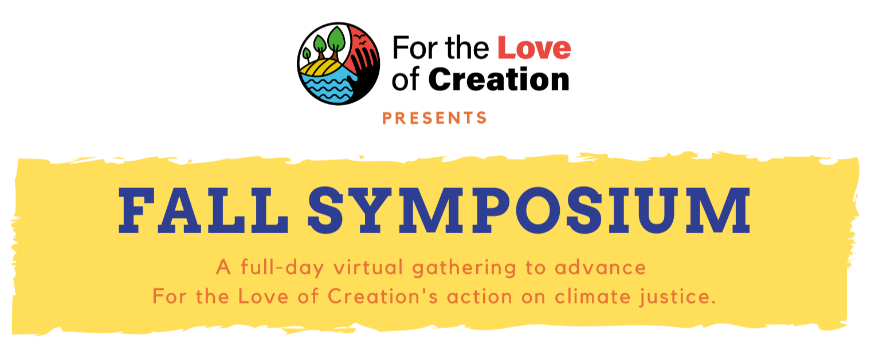

Saturday, October 30 | 11-5 pm EDT
Start time: 8 am PDT, 9 am MDT, 10 am CDT, 11 am EDT, 12 pm ADT, 12:30 pm NDT
The 2021 Fall Symposium will mark a key moment in the For the Love of Creation journey, in Canada’s climate plan, and in global climate action as we engage with COP 26 (November 2021). It is intended to bring together people to learn more about climate change and climate change advocacy from a faith perspective. We will hear from the collective reflection and writing process called the Letter of the Faithful that engages in a process of theological reflection and discussion around climate change, learn more about our climate advocacy goals and how they have evolved, and network with others in our regions around local climate action.
https://secure.kairoscanada.org/civicrm/event/info?reset=1&id=251

Day of Action to Protest Funding of Fossil Fuels As we approach the critically important global climate talks in Glasgow, we are coming together to demand “fossil banks” like RBC stop funding fossil fuels. On Friday, October 29th, people around the world are planning a day of action against the biggest funders of climate chaos. In Canada, that means Canada’s biggest fossil bank, RBC, needs to feel the pressure from coast to coast to coast. So far the only event in our diocese is at RBC, Waterside Centre, 1871 Lower Water Street, Halifax hosted by Richard Peisinger 12pm https://rbcrevealed.com/oct-29th-action-map/

A Message from Halifax Kairos In Preparation for COP26 As part of their ongoing work for a just and sustainable recovery, the ecumenical social justice Halifax Kairos Group is encouraging churches to find meaningful ways to include these concerns in your faith community communications, gatherings and advocacy prior to COP26 that begins October 31.
The poet of long ago said that “there is a moment to decide’ and that moment is before us as delegates, world leaders and passionate people gather in Glasgow, Scotland for COP26 (Conference of the Parties). Each of these United Nations Climate Change Conferences seeks a way into the future that will protect the environment and make serious decisions about how to tackle climate change. This time the work is considered to be the last best hope.
Each of us has a part to play. As faith communities we have rich traditions that address our intimate connection with the created order. Prayer resources can be found in many places including: https://www.faithclimateactionweek.org/prayers-and-climate-blessings
For more information, please email lindakseven@gmail.com

Petition to Trudeau before COP
COP26 is only 3 weeks away. This crucial global summit is an opportunity for Trudeau to commit to bold and necessary action to tackle the climate emergency. Since 2015, Trudeau's climate plans have fallen short of what scientists say is required. If we demonstrate that tens of thousands of people across the country expect Trudeau to commit to bold and necessary climate action at COP26, we could force him to step up his game.
Petition for energy efficient building codes
For those who tweet: Buildings are expected to play a primary role in achieving climate neutrality and the development a retrofit code, alongside a stringent model code for new buildings, has been identified as key to reaching climate neutrality in our built environment. Reaching the deep energy and emissions reductions needed in our built environment demands the federal government step up and aligns our national model codes with federal climate commitments. Tweet federal leaders.

Climate Code Red info
Have you signed the paper petition to Parliament yet? Initiated by the Council of Canadians with many groups joining in. A demand to the federal government to implement just transition legislation in the first 100 days of Parliament. People are collecting 25 signatures on a paper federal government petition and taking to an MP who hopefully will be persuaded to table it in Parliament and speak to it. If you can't find someone with a petition to sign, maybe start your own! Scientists have issued a “code red for humanity” to tackle the climate crisis, but governments continue to let corporations call the shots. With your help, we can break the grip of corporate influence. Organize your community to pressure MPs to support just transition legislation. For more info: https://canadians.org/analysis/climate-code-red-week-action-just-transition-legislation
Petition against insuring oil and gas projects
Thomas Buberl, AXA CEO is considered the most active climate leader within the insurance industry. In 2017, he stopped insuring new coal projects. AXA’s move was followed by many insurers and coal has now become almost uninsurable. However,
AXA continues to insure the exploration of huge oil and gas reserves, including in fragile ecosystems near the mouth of the Amazon River which are home to blue whales, manatees and other threatened species. In 10 days, AXA could adopt a breakthrough new climate policy -- but you can bet oil and gas lobbyists are not going to stand by idly. Please tell Thomas Buberl to take the lead on climate by ending all support for new oil and gas projects!

Ozone layer
Back in 1970 to 1990s, the environmental news was already talking about how greenhouse gases are killing our ozone layer. Stories were told of this gaping hole in the ozone layer over Antarctica. Anything to do with the environment had a reference to this Ozone Layer.

Now there is the possibility that I missed the email, the news break, the epic celebration when it was discovered that the ozone layer was HEALING. Back in 2018, the United Nations gave a report that the ozone layer will be completely healed by 2050.

https://news.un.org/en/story/2019/09/1046452
https://www.bbc.com/news/science-environment-56014092
With all the work we need to do to heal all the planet, maybe this news did not seem like a big win. I disagree! Humans are working to help their planet AND IT IS WORKING! That’s reason enough for a party.

Why do we need the ozone layer? One reason is that it protects us from ultraviolet rays that can cause cancer. Without this shield ice melts faster, oceans rise, and a cycle of bad possibilities happens.

SO why aren’t excited over the healing?

It all has to do with ozone-harming CFC chemicals. Right now there is a reduction in the gaping hole of the ozone layer because companies are making fewer CFC chemicals.

So why don’t we stop making CFC chemicals? It makes sense. No chemicals, no ozone holes, fewer problems.

One use of CFC chemicals is in the making of aerosol sprays. It is in that spray air freshener, hair spray, and even Grandma’s cooking spray to grease her pans. They all are connected to the condition of the ozone layer.
Do you remember Grandma talking about the POWER OF ONE? It is when one person tells one more person about something. They each tell one person who each tell one more. The numbers grow 1,2,4,8,16 and so on.
The power of one is working with aerosol sprays. We are using more squirt type of bottles. It was easy for Grandma to give up hair sprays. Giving up cooking sprays was not as easy. Yes, I do grease my pans now with a bit of oil and wax paper, except for muffin tins. They always stick without spray oil. The difference is that Grandma went from maybe 6 baking spray bottles a year to one.

Grandma is reducing the amount of CFC chemicals she put out on the air currents. So did a whole lot of other people. One small step by many people makes something happen. What are you willing to give up or change to another method of doing things to help our planet?

Together there are fewer chemicals and the ozone layer is healing. Grandma sees that as a reason to party. Put on the tea. Bring out the cookies. Let’s celebrate.

Make a Sun Dial
To tell time with a sundial you will need 12 rocks or maybe shells.
One stick, rod, something upright (What can you repurpose?)
Paint or markers
Clean your stones or shells and paint numbers 1 to 12 on them
A sundial takes a bit of work but is a neat thing to use year-round. After the first one is made you can improve on it.
Find a spot that is sunny most of the day. Place your stick in the ground.
We all know the face of a clock (nothing digital here). The shortest shadow that the stick gives you should be 12 noon.
It takes a couple of days to get the markers where they should be. Then you can use the sundial like an ANALOG clock. I know, the world is digital, but no harm in learning a few old-school things.
Then it is time to go play. Check your watch and set your marker to the time. We set an alarm for every hour and went to the sundial and set the stone
I found a few references on making sundials.
Video
https://www.youtube.com/watch?v=-_lp_usCb5Y
https://www.youtube.com/watch?v=Gxo8orZ1X7g
Website
https://www.kcedventures.com/blog/how-to-make-a-sundial-for-kids
https://www.raritanheadwaters.org/2020/04/16/make-a-sundial/

Picture from https://www.kcedventures.com
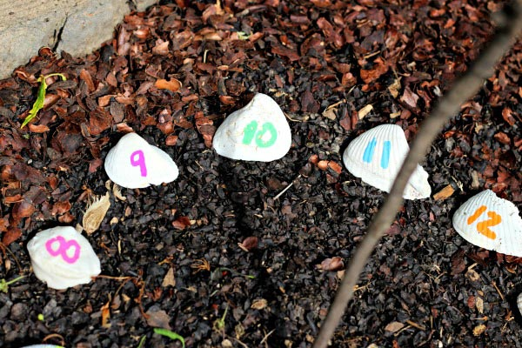
Something to eat
At our house, we love cranberry sauce with our turkey. There always is a big bowl of cranberries with chicken or turkey. There always is a lot left over after the meal. I use up that cranberry sauce by making Bog Bars. Think of date squares with cranberries in them.

BOG BARS
1 ¼ cup butter
1 ½ cup brown sugar
3 ½ cups oats
1 cup flour
1 can of cranberries or a cup /4 of this mixture into the bottom of a greased or two of leftover sauce
½ cup chopped nuts (walnuts, almonds, or pecans)
Mix butter and brown sugar and add in oats and flour.
Press about ¾ of this mixture into the bottom of a greased 9 x 13 pan. Add a layer of cranberry sauce. Add the nuts. Sprinkle the remaining oat mixture on top. I dab a little butter on top of that and bake at 350 for about 25-30 minutes. Cool and cut in squares.

Pray for leaders and politicians:
Leader: God, we pray for you to raise up a generation of leaders with the courage to take responsibility for our changing climate, and the part we have played in it. We intercede for our politicians and leaders – cause them to act in the best interests of all nations today, and all peoples in the future, in order to avoid catastrophic changes. We ask for a generation of leaders who will be willing to act justly so that those who have contributed so little to the problems we are facing, and have fewer resources with which to face it, are not left to shoulder our burden. We ask for you to fill the hearts of all who lead rich nations – give them your mercy and compassion on poor countries already suffering the effects of a changing climate. Just as they have been moved to cancel debt in the past, encourage them also to release funds so that poor communities can adapt to the effects of climate change, and develop cleanly.
All: God, in your mercy, lead our leaders to truth, and transformation.
The SanctuaryCentre http://www.thesanctuarycentre.org/resources/writtenprayers-prayers-in-response-to-cli mate-change.pdf

