October 12, 2021
Email: endionspei@gmail.com Website: nspeidiocese.ca/den
Facebook: Environment Network Diocese of NS & PEI
Welcome to our weekly Enews.
The Diocesan Environment Network (DEN) of the Anglican Diocese of NS & PEI, was formed in response to the Fifth Mark of Mission and the latest addition to our Baptismal Covenant which has become our Mission Statement.
“To strive to safeguard the integrity of creation and sustain and renew the life of the earth.”
To do this we educate and encourage stewardship through social media and liturgies, connect with other environment groups, pray together, celebrate art with each other and grieve together.



Thursday Night DEN Gatherings – October 14th @ 7pm via Zoom – Family & Youth Ministry VSST with Rev. Kristen and Allie Colp
The Youth and Family Ministry VSST (vision, strategy, and support team) is comprised of youth (aged 12-18), young adults (aged 19-25), lay people of various parishes and regions of the diocese, clergy of the diocese, and staff support (the Youth and Family Ministry Coordinator). Our team strives to interpret the Diocesan Vision of being a “Christ-centred, mission-minded, ministering community of faith” in light of the children, youth, and families who are currently within the Anglican community and with those of the wider community. This ministry is carried out by various task groups of the team including: the Diocesan Youth Conference (an annual event for youth aged 12-18), a Young Adult Retreat (an annual event for ages 19+), the Connect workshop series for youth ministry (Plans and facilitates training sessions offered in regions, parishes, and for diocesan youth events), and the Welcoming Families task group (Creates resources and provides support to parishes in ensuring that families are fully included in the life of the church, and works to ensure that diocesan policies support the involvement of parents in diocesan life.) In addition to these ongoing groups the VSST also visions and plans for new opportunities such as the return of the Community Roots camps, creating safe and inclusive spaces in the Church, social justice and advocacy work, and assisting groups navigate resources for leaders in parishes.
Rev. Kristin MacKenzie is rector of the Parish of Liscomb Port Bickerton and Priest in Charge of the Parish of Three Harbours. She was appointed team lead of the Youth and Family Ministry VSST in the spring of 2021, previous to this she has taken part and led in youth and family based such as the Diocesan Youth Conference (DYC), the Canadian Lutheran Anglican Youth Conference (CLAY), the Young Adult Retreat, as well as parish based ministries in these areas. She lives in Sherbrooke with husband, Mike, their son Samuel, as well as two amazing cats Scout and Magnificat.
Allie Colp is the Youth and Family Ministry Coordinator for the Diocese of Nova Scotia and Prince Edward Island. Allie has a Bachelor of Environmental Science, with a major in Environmental Biology, and integrates that knowledge and passion for the environment into much of her ministry. She lives in Amherst with her husband, Will, and their son, Simeon, and she spends much of her free time sewing clothes for her family.
Kairos Times Newsletter – click on the link to view in your browser
https://secure.kairoscanada.org/index.php?q=civicrm/mailing/view&reset=1&id=1133


Green Cent$
November 18-20, 2021. Save the dates!
____________________________________________________
A ZOOM Symposium sponsored by the Diocesan Environment Network, Diocese of Nova Scotia and PEI - The DEN. Join us on Thursday, November 18th, 7:00 PM, as we gather to hear our first speaker, Bishop Sandra.

Green Cent$ is about people, liturgical practices, building and site management. It is for all church people - those who already have experience in greening their church, as well as those who feel they have a lot to learn. It is for people of all ages and all talents. There is a role for everyone in greening our churches - we are all in this together.

We will look at:
Why we want to green our churches.
How to do it.
Where to find funding.
Sessions will be presented Thursday and Friday 7pm to 9 pm and
Saturday 10-12am and 1-3pm.

We are inviting speakers at this time.
If your church has a greening program already, why not share what you have accomplished during the Green Cent$ Program Case Study Session. Please Contact: endionspei@gmail.com

Diocesan Environment Network, Diocese of Nova Scotia and PEI - The DEN. 14/9/21
Dr. Margaret Bateman Ellison, GREEN CENT$ Zoom Symposium Coordinator



Join the Climate Code Red week of action from October 12-17th to demand the federal government implement just transition legislation in the first 100 days of Parliament. Scientists have issued a “code red for humanity” to tackle the climate crisis, but governments continue to let corporations call the shots. Participate in the week of action by clicking here for your toolkit: https://canadians.org/analysis/climate-code-red-week-action-just-transition-legislation?utm_source=Council+of+Canadians&utm_campaign=c941afe7d3-EMAIL_CAMPAIGN_2021_01_27_08_08_COPY_01&utm_medium=email&utm_term=0_f477a42a0b-c941afe7d3-384099924&mc_cid=c941afe7d3&mc_eid=5aac9d93f5

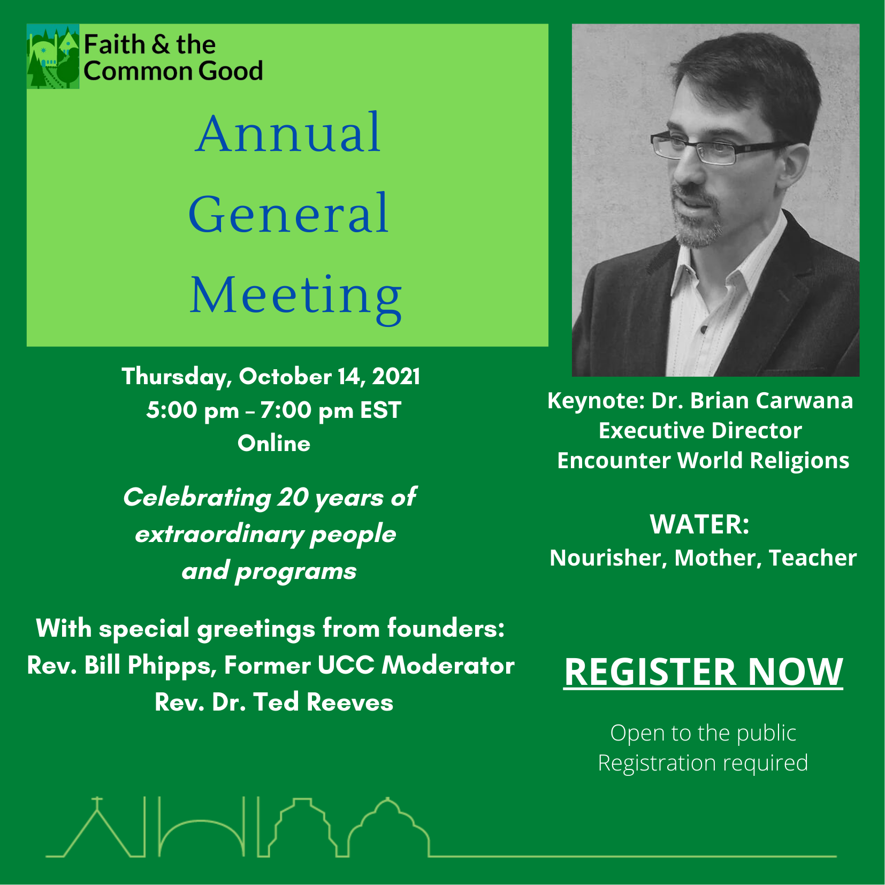
You are cordially invited to join with the whole Faith & the Common Good network across the country in celebrating of 20 years of extraordinary people and programs that have harnessed the power of diverse faith and spiritual groups to build more resilient and sustainable communities! Thursday, October 14, 2021 5:00 pm – 7:00 pm EST
REGISTER NOW to receive the Zoom link
https://www.faithcommongood.org/fcg_agm?utm_campaign=fcg_agm_2021_invite&utm_medium=email&utm_source=faithcommongood
With special greetings from founders: The Very Rev. Bill Phipps, Former UCC Moderator and Rev. Dr. Ted Reeves.
Our first virtual Annual General Meeting (AGM) is open to the public. We are inviting our partners and funders to join us and hear about the impact your support has made.
Our keynote speaker is Dr. Brian Carwana, Executive Director of Encounter World Religions. As an associate with the Canadian Centre for Diversity and Inclusion he has delivered innovative programs to some of the country’s largest and most forward-thinking companies. To learn more visit worldreligions.ca or Brian’s personal site and blog at ReligionsGeek.com. You can follow him on Twitter @ReligionsGeek.
Brian’s presentation is:
Water: Nourisher, Mother, Teacher.
Water is magic. It is the source of all life, the primary means of cleanliness and purity, and brings joy, making us want to play in it. The world's great spiritual traditions have been drawn to, incorporating it in ritual, story and mythology. In this talk, we will explore how some of the world's great spiritual traditions have engaged with this element, so central to our existence and at the very heart of nature.
While we cannot meet in person again this year, we look forward to having you join us to share successes, reflect on the past year, and discuss the vision for the year ahead.
Sincerely,
Michelle & the FCG Team
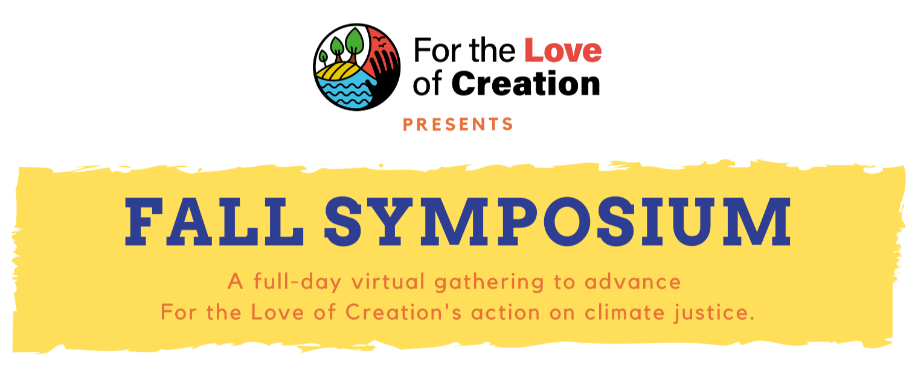

Saturday, October 30 | 11-5 pm EDT
Start time: 8 am PDT, 9 am MDT, 10 am CDT, 11 am EDT, 12 pm ADT, 12:30 pm NDT
The 2021 Fall Symposium will mark a key moment in the For the Love of Creation journey, in Canada’s climate plan, and in global climate action as we engage with COP 26 (November 2021). It is intended to bring together people to learn more about climate change and climate change advocacy from a faith perspective. We will hear from the collective reflection and writing process called the Letter of the Faithful that engages in a process of theological reflection and discussion around climate change, learn more about our climate advocacy goals and how they have evolved, and network with others in our regions around local climate action.
https://secure.kairoscanada.org/civicrm/event/info?reset=1&id=251

Petition from StandEarth for old growth forests The last giants are falling in British Columbia. Old growth forests, home to tall, ancient trees, are still being commercially logged. Now, less than 1% of forests in B.C. are home to stands of large, old trees. This destruction affects communities across Canada. Healthy, old growth forests clean the air, shield us from fire and flooding, and store massive amounts of carbon. Once logged, it takes hundreds of years to recover the majority of that stored carbon. Protecting old growth forests is one of the most effective things we can do to mitigate the impacts of climate change.
Petition asking federal government for strong climate action

The climate crisis won’t wait. Call on all federal parties to cooperate on climate action. Top climate scientists issued a “code red for humanity” recently, warning that this is our last chance to implement the transformational changes necessary to keep warming below 1.5 C and avoid the most dangerous impacts of climate chaos. Canada’s climate targets are still critically insufficient. We are the only G7 country whose emissions have increased since the Paris Agreement was signed.
Petition to ban the insecticide imidacloprid
Other countries have banned imidacloprid. Will our Canadian government let Bayer keep pumping it onto our crops? A new study shows that this pesticide is wiping out squash bees - an essential crop pollinator A ban should be a foregone conclusion. But the pesticide lobby spends millions strong-arming politicians to protect their business. And the only way we can stop them is to drown out their lobbyists with our voices.
Information on Code Red Week of Action

The Council of Canadians working with other groups have organized the Climate Code Red week of action from October 12-17th to demand the federal government implement just transition legislation in the first 100 days of Parliament. People are collecting 25 signatures on a paper federal government petition and taking to an MP who hopefully will be persuaded to table it in Parliament and speak to it. If you can't find someone with a petition to sign, maybe start your own! Read the toolkit and sign up to join in Scientists have issued a “code red for humanity” to tackle the climate crisis, but governments continue to let corporations call the shots. With your help, we can break the grip of corporate influence. Organize your community to pressure MPs to support just transition legislation.

COP, climate change and hunger Climate change is increasing food insecurity around the world. Canada has a role to play. Canadian Foodgrains Bank is inviting Canadians in its large network to support the work of ending global hunger by using their voice! Tell Canada’s leaders to make a bold statement in Glasgow, at COP this November, and to fulfill the promises made on supporting greater adaptation to climate change. We know that food producers around the world have enough challenges to deal with in feeding their families and communities—let’s make sure the world doesn’t forget them in the fight against climate change. Send an email to our Canadian leaders, asking them to act now. It will only take a couple of minutes. Click on the link below to use our easy, online letter builder
https://foodgrainsbank.ca/online-letter/

Flower masks
Hello all. As you know Grandma loves to find environmental stories to tell you. There are so many different programs or inventions or activities to talk about.
This week I want to talk about masks, face masks, the type we have been wearing over this pandemic.
There are 2 stories I am excited about.
First, think about all the masks and gowns our hospitals and medical centers use in a day. What happens to them?
They were being sent to landfills. Do you know it takes 450 years for the masks to decompose in a landfill?
How many do you think went to landfills?
It is estimated that globally 129 billion facemasks and 65 billion plastic gloves are thrown away every MONTH.
Over in England, a company called the Thermal Compaction Group has found a way to turn the PPE into plastic blocks. The blocks are sterilized and can be used as a base to make most other things that are plastic
https://www.ctvnews.ca/sci-tech/this-machine-can-help-turn-used-ppe-into-almost-anything-1.5420589
I thought that was the neatest thing in the world. Then I learned that they are making those clear face shields from repurposed masks, and even made a biofuel from them. Read some more here
https://www.ctvnews.ca/sci-tech/this-machine-can-help-turn-used-ppe-into-almost-anything-1.5420589
or
https://www.cbc.ca/kidsnews/post/masks-are-polluting-the-environment.-these-4-companies-have-solutions
PLASTIC IS NOT BAD; It is how we use and abuse plastic that is bad. When we find ways to recycle or repurpose plastic, it stops being a pollution and begins being a resource.
THEN
While we are talking masks, here is a new idea. Annoyed with so many masks just littered across the land, this manufacturer decided to put them to good use.
She made a disposable mask that has flower seeds implanted in the material. The idea is to wear the mask and then plant it so next year flowers to help the bees grow all over the landscape.
Even the ear loops are made from wool spun thick enough to be sturdy.
Grandma likes the idea but is concerned of people and allergies or if people would take the time to plant them. Even string takes time to break down.
Go see what this is like at
https://www.countryliving.com/uk/news/a35804769/biodegradable-face-masks-flowers/
or
https://www.brightvibes.com/2206/en/these-fully-biodegradable-face-masks-grow-into-flowers-when-buried
Now for our younger membership, Grandma found a few videos
https://www.youtube.com/watch?v=wRYfw5hIWwM
https://www.youtube.com/watch?v=hXp8bK3C8qA
Craft Time
This week Nana and I made dancing princesses. They are bright, colourful and fun to make.
You will need
Pipe cleaners
Napkins or coffee filters or tissue paper
A bit of string, yarn, or thread
Fold the two pipe cleaners in half, on one make a head shape. Using the second one, wrap the pipe cleaner around the first one to make a small body
Next, we need to make the dress with the big frilly skirt.
Using a napkin, make a small hole where the middle is.
I liked to use a bit of scrap paper to cover her shoulders. Then insert your dancer in the napkin and tie the dress in place with that thread or yarn.
Making sure not to cut her legs, trim the skirt of her skirt with scissors. Then arrange legs and arms in ballet or other forms of dance. I have a few pictures of ours. We like to hang crafts or pictures on a mobile Nick gave Nana years ago. Yes, that is a tomato on one of the skirts.
Have fun.
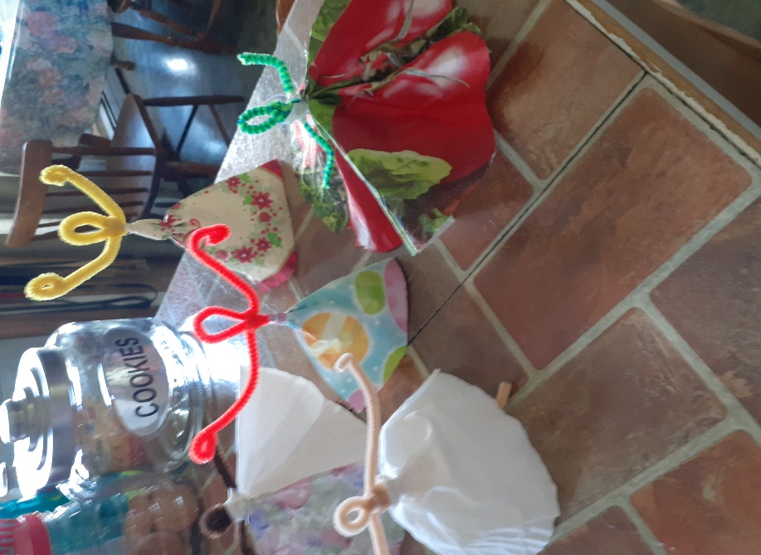 | 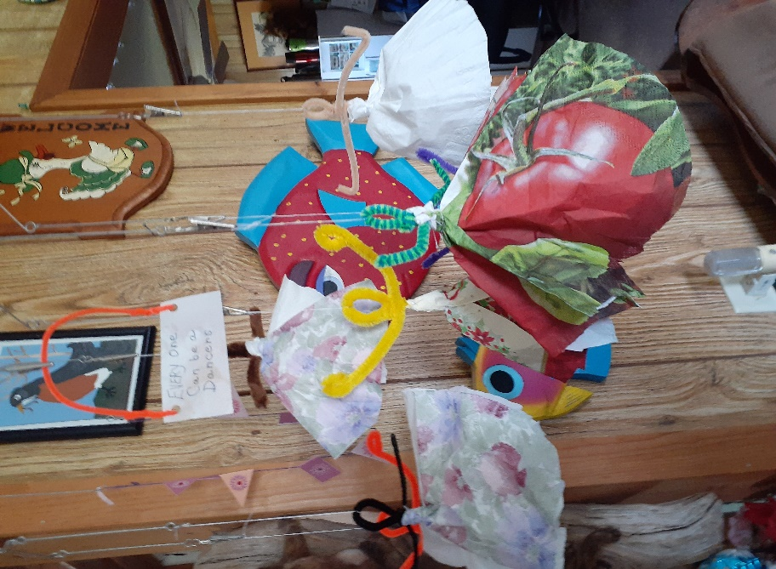

Something to eat
Anyone know what a Cuddy Pie is? Some people call them hand pies. Often baked on a saucer in our house, they were the leftover dough with anything in the middle, sometimes even jam.
Why were they called Cuddy Pies? The men took them as part of their lunch when they were fishing in small open boats. In the front of the boat, before there were cabins, there were cuddies. Think of a small cupboard where they kept an extra pair of socks, some of the fishing equipment and their lunch basket. Hence the name cuddy pies. It usually was the first pie a girl learned how to make.
Hand pies are close to the same, but you start out planning to make small pies.
Cuddy pies often meant rolling out the left-over dough. Grease an old saucer and lay the dough on the saucer. The dough is as large as it is, overhanging the saucer. Place the pie filling in the middle and fold in the sides to cover it all. Bake.
Hand pies: You roll out your dough and use a small saucer or a large round cookie cutter to cut out your dough. Add the pie filling on one half of the dough. Fold over the dough and pinch the dough shut. A pan full of hand pies disappear rather fast. I found this picture on
https://www.aheadofthyme.com/25-best-thanksgiving-dessert-recipes/

Till next week, Grandma is sending hugs

Giving Thanks
For the expanding grandeur of creation, worlds known and unknown, galaxies beyond galaxies, filling us with awe and challenging our imaginations:
We give thanks this day.
For this fragile planet earth, its times and tides, its sunsets and seasons:
We give thanks this day.
For the joy of human life, its wonders and surprises, its hopes and achievements:
We give thanks this day.
For our human community, our common past and future hope, our oneness transcending all separation, our capacity to work for peace and justice in the midst of hostility and oppression:
We give thanks this day.
For high hopes and noble causes, for faith without fanaticism, for understanding of views not shared:
We give thanks this day.
For all who have labored and suffered for a fairer world, who have lived so that others might live in dignity and freedom:
We give thanks this day.
For human liberty and sacred rites; for opportunities to change and grow, to affirm and choose:
We give thanks this day.
We pray that we may live not by our fears but by our hopes, not by our words but by our deeds.
We give thanks this day.
- O. Eugene Pickett
https://www.xavier.edu/jesuitresource/online-resources/prayer-index/thanksgiving-prayers

