September 28, 2021
Email: endionspei@gmail.com Website: nspeidiocese.ca/den
Facebook: Environment Network Diocese of NS & PEI
Welcome to our weekly Enews.
The Diocesan Environment Network (DEN) of the Anglican Diocese of NS & PEI, was formed in response to the Fifth Mark of Mission and the latest addition to our Baptismal Covenant which has become our Mission Statement.
“To strive to safeguard the integrity of creation and sustain and renew the life of the earth.”
To do this we educate and encourage stewardship through social media and liturgies, connect with other environment groups, pray together, celebrate art with each other and grieve together.



Thursday Night DEN Gatherings – There will no gathering on Sept. 30th. We encourage you to attend Truth & Reconciliation events in your community. Here are some resources for reflection and education:
https://nctr.ca/
https://nctr.ca/about/history-of-the-trc/trc-website/

Green Cent$
November 18-20, 2021. Save the dates!
____________________________________________________
A ZOOM Symposium sponsored by the Diocesan Environment Network, Diocese of Nova Scotia and PEI - The DEN. Join us on Thursday, November 18th, 7:00 PM, as we gather to hear our first speaker, Bishop Sandra.

Green Cent$ is about people, liturgical practices, building and site management. It is for all church people - those who already have experience in greening their church, as well as those who feel they have a lot to learn. It is for people of all ages and all talents. There is a role for everyone in greening our churches - we are all in this together.

We will look at:
Why we want to green our churches.
How to do it.
Where to find funding.
Sessions will be presented Thursday and Friday 7pm to 9 pm and
Saturday 10-12am and 1-3pm.

We are inviting speakers at this time.
If your church has a greening program already, why not share what you have accomplished during the Green Cent$ Program Case Study Session. Please Contact: endionspei@gmail.com

Diocesan Environment Network, Diocese of Nova Scotia and PEI - The DEN. 14/9/21
Dr. Margaret Bateman Ellison, GREEN CENT$ Zoom Symposium Coordinator

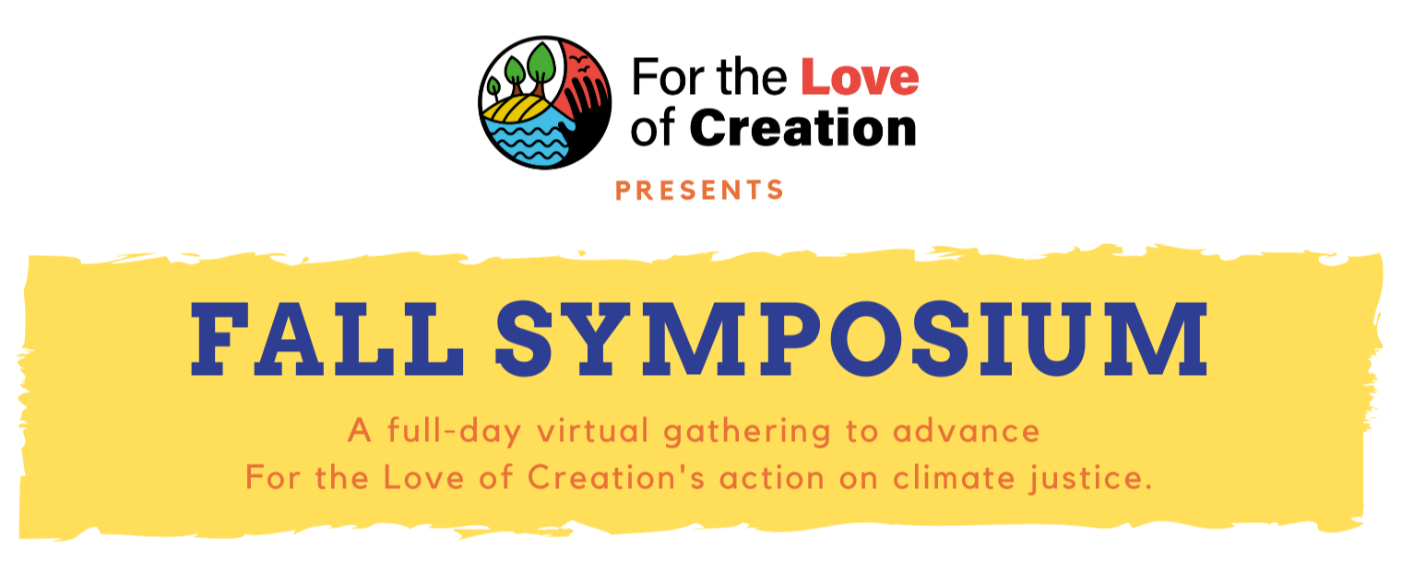

Saturday, October 30 | 11-5 pm EDT
Start time: 8 am PDT, 9 am MDT, 10 am CDT, 11 am EDT, 12 pm ADT, 12:30 pm NDT
The 2021 Fall Symposium will mark a key moment in the For the Love of Creation journey, in Canada’s climate plan, and in global climate action as we engage with COP 26 (November 2021). It is intended to bring together people to learn more about climate change and climate change advocacy from a faith perspective. We will hear from the collective reflection and writing process called the Letter of the Faithful that engages in a process of theological reflection and discussion around climate change, learn more about our climate advocacy goals and how they have evolved, and network with others in our regions around local climate action.
https://secure.kairoscanada.org/civicrm/event/info?reset=1&id=251

New Resource! Creation Care as Self-Care - Contemplative Journal

This contemplative resource is a creative arts journal to support you in an intentional and restorative relationship with yourself as a part of Creation. You can do this workbook alone or in a small group, with gathering and centering rituals according to your tradition. The journal is accompanied by three prayerful meditations. Download the pdf file here:

https://fortheloveofcreation.ca/wp-content/uploads/2021/09/ForTheLoveOfCreation_Workbook_English_FINAL.pdf

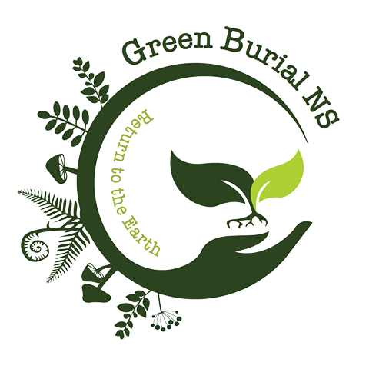

Green Burial Café – TOMORROW

With Mark Richardson.

President of the Green Burial Society of Canada.

Wednesday, Sept 29th at NOON on Zoom.

Here's the Zoom link:
https://us02web.zoom.us/j/87392711263?pwd=Uy9KekRIeGpYaHh1cGhMbHNKVERodz09
And the password: Green

Petition to Federal Leaders

The Liberals, NDP, and Greens combined have enough seats to form a stable majority. They’ve committed action on important issues,
including bold action to tackle the climate crisis and inequality. It’s a huge opportunity to make progress. This petition is calling on them
to work across party lines to cooperate and ensure a climate-safe and just future for all.

Petition to stop pesticide companies influencing UN
There are an estimated 385 million cases of acute pesticide poisonings each year. That means about 44% of farmers and agricultural workers around the world are poisoned annually. And those numbers could rise if we don’t stop Bayer’s latest power grab. Right now, the UN Food and Agriculture Organization (FAO) is trying to create a formal partnership with CropLife International -- the mega lobbying group that represents Bayer, Cargill, Syngenta and over 300 other pesticide companies.
Petition telling our big banks to stop financing fossil fuels
The big five banks in Canada are all within the top 25 fossil fuel financiers in the world. Even since the Paris climate agreement was signed five years ago, urging for assertive global action to avoid climate catastrophe, they have steadily increased their support for fossil fuels.

Petition to protect Water Resources
Water is one of our most precious and valuable natural resources, but the water we need to survive is at risk; threatened by pollution, overuse, and climate change. Sign the pledge to protect water, fight climate change, and advance solutions for a water resilient future.

Petition to Protect Artic from Oil and Gas Drilling
The Arctic National Wildlife Refuge is an area in Alaska that is right across from Canada’s borders. It is home to the Indigenous Gwich'in and Iñupiat Peoples, as well as home to more than 270 species of animals including the polar bear. Oil companies have secured leases to the land, with another lease sale scheduled soon. Let's support Indigenous communities, protect vital wildlife habitat, and keep planet-warming fossil fuels in the ground.

Petition demanding action from Political Leaders
This petition is demanding that our political leaders act today before it is too late! We need to be passing laws and mobilizing resources and people in order to reach our fossil fuel reduction targets. We need to declare a Global Warming Extinction Emergency and do whatever we can to adapt our world for the consequences of our human actions. This petition is for all of us to sign as citizens of the world.

The six-month mark
It has been six months since Rev. Marion (Lucas-Jeffries) asked Grandma to write for DEN.
Rev. Marion has a way of getting people involved. When Messy Church was started in the Parish of Blandford; it was Grandma that became the organizer of the gathering craft.
As families came in, the children ran to Grandma to find out what they were making that night. We would work along until we were called to our service.
Grandma tries her best to write like I am talking to an 8-year-old.
Why an 8-year-old? An 8-year-old has enough knowledge to read and write. They have enough experience with crafts or projects that they can adapt to whatever new is happening quickly AND help the younger ones get there too. They are natural teachers. They are enthusiastic. They think outside the box. They see things that the older folks can’t right then.
I want to introduce you to Frankie Moreland. One of the things about this eight-year-old young man was a marvelous song he wrote with his Dad about the World in Danger.
You can hear the song here.
https://www.youtube.com/watch?v=Hb-ZiYuLuQg
Frankie and his Dad had a video interview at a TV station here
https://www.youtube.com/watch?v=MwseIiJ0PIM
The schools are teaching environmental facts from the first day our children enter their schoolhouse. They will be the ones in the future that aren’t just thinking “something has to be done”; they will be doing it. They won’t understand how we lived in a world before all the Rs. All we need to do is to keep helping the environment until they grow up to finish the dreams of environment activists of today
Go hear Frankie’s song. He sees his World in Danger. That tells it just about right.
Box Baskets
Grandma is known for painting boxes in plain colours. They make a tray of whatever you are carrying, look a bit brighter. They reuse what we have or repurpose a box into something new. This week we are making wastebaskets.
Find a box, cut off the top flaps, and paint the box. Some people prefer to wait till the end and spray paint the entire “basket”

Make paper rolls like the fire starters or the wands of the pinwheel. (In case you forgot; take a sheet of newspaper. At one corner start rolling the paper around a pencil. When finished, loosen the roll a bit and slide the pencil out. Tape the roll in place.) Then flatten each round. I do this by pressing them against the side of a counter | 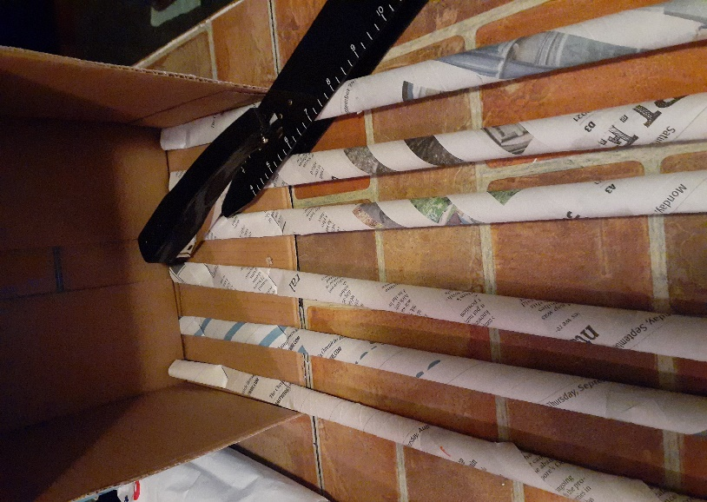
Finding a stapler and placing the box on its side, staple the upright wands onto the insides of the box. Staple the rods at the top and bottom or at least the same height on the box all the way around. The staples will come through the cardboard. When you are finished weaving you can add a row of tape or other trim over the staple points to avoid pricking yourself. For this project place an even number of wands. (Usually, we weave an uneven number but this weaving will be completed one row at a time)  Starting at any point at the top of the box where the wands start, weave the flattened newspaper rods in and out of the uprights. When you finish a row it is easier to cut off the excess and staple or tape the two ends together. | 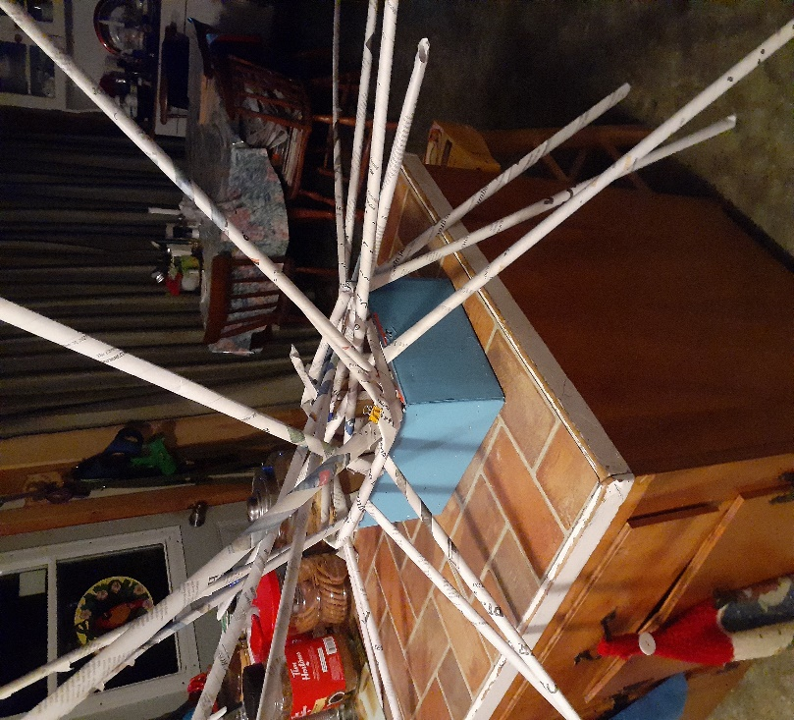
By now you have a creature resembling an octopus with 20 some arms. To make it easier for the first few rows, gather all the upright arms and tie them with an elastic band.  Start weaving the second row one rod over so the weaving looks like a basket weave. After 3-4 rows the weaving will hold the rods upright and the elastic can be removed. I also use clothes pins to hold the weaving tight in those first few rows. Practise makes it easier.  The basket can be as small or tall as you want. On the top row. tuck the upright rods over to the inside and staple. | 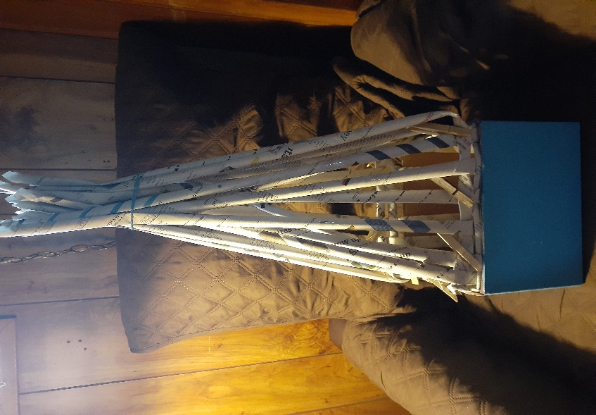
You can run a row of duct tape around the top for decoration.  You can spray-paint the entire thing. If the bottom is already painted just gently paint the newsprint with a brush. Stickers look great on the sides.  Grandma uses one basket box for what she calls “Emergency Craft Supplies” It has a little bit of everything in it. Chalk, markers, pencils, pens, tape, elastics, stickers, two-way tape, glue, drawing paper, colouring pages, crayon, tissues, pins, and at least one storybook.  Go look for other small boxes that come into the house that can be used for more box baskets. | 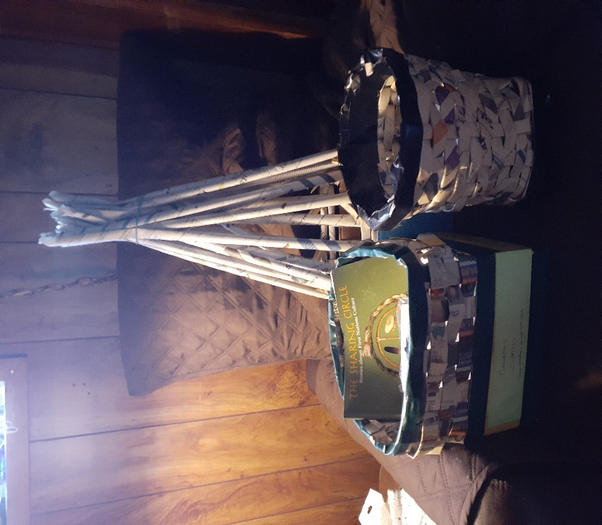

Something to eat
Grandma has several frypans that can go straight into the oven if needed. They don’t have any plastic handles. They are either all steel or cast iron. This is one recipe I use for an afternoon snack if the Grandbabies have been outdoors playing.
Fry Pan Crumble
In a bowl, add 3 big spoons of butter
a cup or more of granola
2 tbsp each of sugar and flour
Blend it all and set it aside
In the frypan, add a couple of spoons of butter again and add 4-5 apples peeled and sliced thin.
Add 1 tsp lemon juice and some pumpkin spice if you like it. (Cinnamon is my favorite)
Let the apples cook for 4-5 minutes and add the granola mixture. Mix and stir a few more minutes till juicy and bubbly. Put in dishes and add some cream (or ice cream) It makes a wonderful snack or just plain great dessert.
…………………….
Grandma is hurrying to get the last things out of the garden. I always have time to answer emails so write me with your ideas at caz@grandmasgoinggreen.
Prayer for Reconciliation
Holy One, Creator of all that is, seen and unseen,
of story and of song, of heartbeat and of tears,
of bodies, souls, voices and all relations:
You are the God of all truth and the way of all reconciliation.
Uphold with your love and compassion all who open their lives
in the sacred sharing of their stories.
Breathe in us the grace to trust in your loving forgiveness,
that we may face our histories with courage;
touch us through the holy gift of story
that those who speak and those who listen may
behold your own redeeming presence;
guide us with holy wisdom to enter through the gates of remorse
that our feet may walk gently and firmly on the way of justice and healing.
Amen.
From the Anglican Church of Canada

