September 21, 2021
Email: endionspei@gmail.com Website: nspeidiocese.ca/den
Facebook: Environment Network Diocese of NS & PEI
Welcome to our weekly Enews.
The Diocesan Environment Network (DEN) of the Anglican Diocese of NS & PEI, was formed in response to the Fifth Mark of Mission and the latest addition to our Baptismal Covenant which has become our Mission Statement.
“To strive to safeguard the integrity of creation and sustain and renew the life of the earth.”
To do this we educate and encourage stewardship through social media and liturgies, connect with other environment groups, pray together, celebrate art with each other and grieve together.



Thursday Night DEN Gatherings have resumed. Join us Sept 23rd at 7 pm for a discussion about The Climate Change Task Force (CCTF)
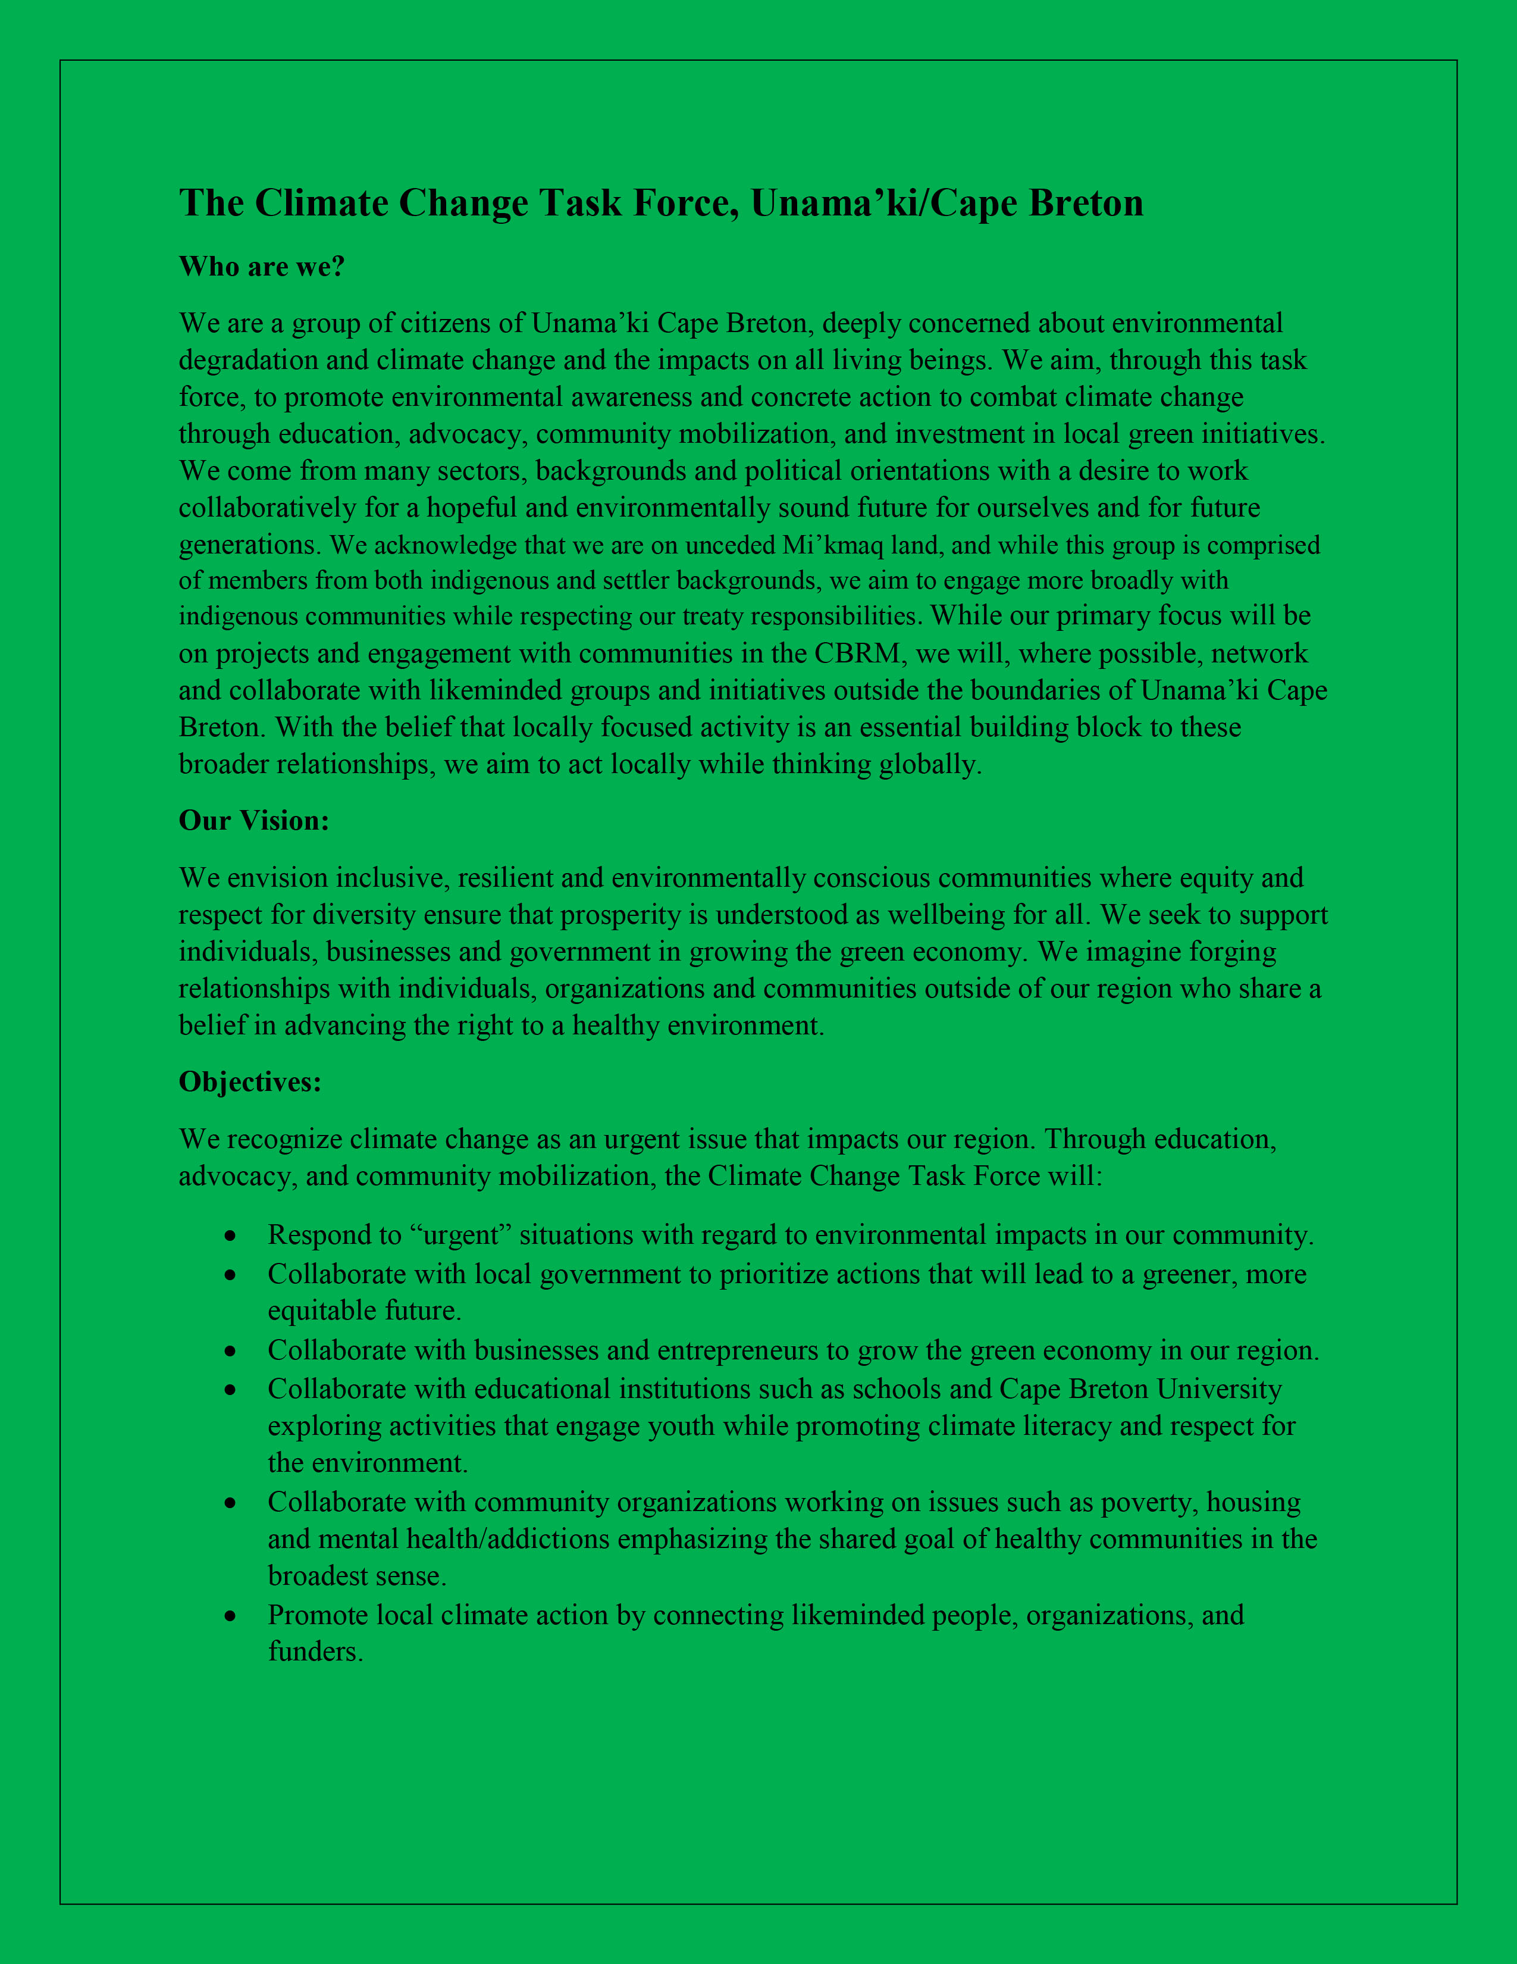

For more information Email endionspei@gail.com
Join Zoom Meeting: https://us06web.zoom.us/j/87171326550
Green Cents – Save the Date DEN will be sponsoring a ZOOM Symposium on Nov. 18th at 7 pm. Green cents is about people, liturgical practices and site management. More details to follow soon!

Friday, September 24 is Kairos Canada’s Global Day of Action for Climate Justice. We invite you to participate in this global day of action by attending a virtual event or in-person climate strike in your community (following COVID-19 safety protocols). Check the Fridays for Future map for events happening in your area. We'll share more resources throughout the week to help you participate in that day.

Kairos Youth Poster Contest - To celebrate its 20th Anniversary, Kairos wants to lift up the work of young artists. Please see this website for more information:
https://secure.kairoscanada.org/civicrm/mailing/view?reset=1&id=1109

Climate Change: Evidence & Uncertainty
Wednesday, September 22, 2021
7:00PM – 8:30PM Central Library

Description What controls climate? How can we simulate a future climate if we can't even simulate the weather accurately a few days out? Are humans really capable of influencing planetary climate? What's in the latest "gloom and doom" report of the Intergovernmental Panel on Climate Change (IPCC)? Who should you believe when it comes to climate change?
Get all the answers from Aldona Wiacek, Associate Professor in the departments of Environmental Science and Astronomy and Physics at Saint Mary’s University
For your safety, in-person programs will follow attendance limits as fitting to the program space and set-up. Participants are expected to be socially distanced, wear masks, and follow the Library's other COVID-19 protocols noted in our Status of Library Service.
Presented in Partnership with Saint Mary's University
NSCC Program – Coastal Protection Environmental Technologies (view details on program page) October 12, 2021
Location: Strait Area Campus, Port Hawkesbury & field camp component on Bras d’Or Lake
Program length: 7 weeks
Admission requirements: Diploma or undergraduate degree in geography, engineering, or marine technologies; or an undergraduate degree in natural or social sciences.
Credential: Certificate of Professional Studies
Tuition: $2,000. View full program fees.
*Bursary value: $2,185. View funding details.
Learn more: Webinar and live Q&A on September 15th from 6:00-6:45pm ADT. Register here.
*Indigenous peoples are automatically considered for additional funds of up to $300/week to help with living expenses while enrolled. To apply, please visit the program page.

Special COP26 Issue from the Anglican Communion Environmental Network The latest news from ACEN includes a new hymn for the Season of Creation which has been used as our Prayer for today. You will also find a number of resources to guide you in the lead up to COP26. https://mailchi.mp/8610c6ceda52/acen-digest-4795590?e=a5d74434ba


The theme this year is “A Home for All”. For more information, check out the DEN webpage: https://www.nspeidiocese.ca/pages/den-season-of-creation--288

2021 09 SOC Holy Eucharist Dio of NS & PEI approved DEN is pleased to pass along a liturgy from Lynn Uzans that was approved for use in the Parish of Wilmot. You can find the link here: https://www.nspeidiocese.ca/ministries/diocesan-environment-network/pages/den-season-of-creation-resources

Kairos Canada’s website DEN Encourages you to explore Kairos Canada’s website for 2021 Climate Action Month for a resource for each day of the month.
https://www.kairoscanada.org/what-we-do/ecological-justice/2021-climate-action-month

Please tell us what your parish is doing. Email your story and photos to endionspei@gmail.com

Petition to COP26 Leaders from around the world are gathering in Scotland to discuss climate change. A group called The Global Prayer and Action chain for Climate Justice are collecting signatures from all over the world for a petition which will be delivered to the COP 26 Presidency in Glasgow in November. It will demand that this round of talks do not end in the same manner as in recent years with, at best, incremental progress and a lack of ambition. It will remind all governments that inaction on climate change translates into innocent lives lost and irreversible destruction to natural ecosystems. Impoverished communities have historically generated a low carbon-footprint. Their contribution to the climate crisis is negligible yet they are amongst the most affected.
Petition to stop aerial spraying in NS Does spraying poison from helicopters on clearcuts in order to kill off natural regrowth of the Wabanaki-Acadian forest sound like something we should be doing in 2021? Corporations are not allowed to create toxic waste dumps on their land, just because they own it. Spraying the land with poison from the air because it is cheaper than paying workers to thin trees on the ground has to stop. This practice has no place in proper forestry. Cape Breton put a moratorium on aerial spraying of herbicides and pesticides years ago. In 2001, Quebec banned the use of glyphosate in forestry. In August 2021, the Nova Scotia Department of the Environment & Climate Change approved applications to spray glyphosate-based herbicides over 1,172 ha (2,895 acres) of private forested land in Colchester, Cumberland, Guysborough, Halifax and Hants Counties.
Petition to stop damaging fracking in Argentina Argentina is a country with an immense range of natural wonders from deserts, forests, waterfalls, mountains, ocean, glaciers, and so much more! It is also one of the most shale rich areas in the world, making it a prime target for fracking operations. Chevron, Shell, ExxonMobile and a subsidiary of BP are all companies working in the area. Footage from workers and satellite images show expansion, improper storage, and spills into the ecosystem. The Mapuche People own some of the land but their rights are being violated and they need global support in order to stand against the big oil companies. Signing this petition and standing with the Mapuche is a way to show support in demanding an end to fracking in Argentina.
Petition to save bees in USA The United States sprays 1 billion pounds of pesticides over its farms and fields every year — and it’s having a devastating impact on pollinators. The pesticides also seep into the soil and groundwater, finding their way to streams and rivers, where they harm fish and other animals. Canadians can add their name to the petition and demand that the EPA save the bees!
Petition to Defend Old Growth Forests BC In many areas of the Kootenays in BC, only 3-4% of the forest is to be retained as Old Growth Management Areas. The remainder can be harvested. There are 14 recommendations outlined in a recent old growth review commissioned by the Province to ensure the protection of this non-renewable resource, but the province has yet to implement any of them. You can help by signing the petition to let the BC government know that it needs to do more to protect old growth forests.


Hi NSEN Members! I wanted to reach out to the organizations today to let you know of a staffing opportunity!
I've been in contact with Canada Green Corps about their Science and Technology Internship Programme and my contact said they have 11 positions they are trying to fill in Atlantic Canada this fall! My contacts name is Liesl Mulholland and her email is Liesl.Mulholland@unac.org.
She wanted me to get in contact with any organizations or businesses that fit their eligibility criteria and I do think that a good majority of you will! I have let her know that I've sent out an email to our members, so please don't hesitate to reach out to her directly, she's looking forward to getting in contact with some great people. You can find their website here, which lists eligibility and requirements for the internship Please reach out to me directly if you have any further fundraising questions! My direct email is sophielamb333@gmail.com.
Thanks for reading!
Sophie Lamb, Fundraising Coordinator ,Nova Scotia Environmental Network
Dear Friends,
Touching the Earth Halifax (formerly EcoDharma) met last Friday to brainstorm an environmental action for GreenFaith's events on October 17-18. We decided on 'picketing' Royal Bank's main office downtown, noon to 1 pm on Monday, October 18th.... with reversible signs saying "Stop Funding Fossil Fuels" and "Invest in Renewables".
We would very like this to be a multi-faith event. Will you join us? Obviously, there is much planning to be done. Perhaps some of you have more experience and expertise in this area.Please let me know if you are interested.... and we will plan the next steps.
Thanks so much for considering.
gratefully, Deborah Luscomb (she/her)
End-of-Life Guide
Touching the Earth Collective
902.403.7590

Wind Turbines
Grandma loves wind turbines. Big ones, little ones, even the paper variety we made the other week. I have even saved some large laundry detergent bottles so I can learn to make a vertical axis wind turbine. They are small turbines but still can generate electricity for a power storage tank
Those big turbines are in every province in Canada. I have a graph below that comes from a government site
https://www.nrcan.gc.ca/science-and-data/data-and-analysis/energy-data-and-analysis/energy-facts/renewable-energy-facts/20069
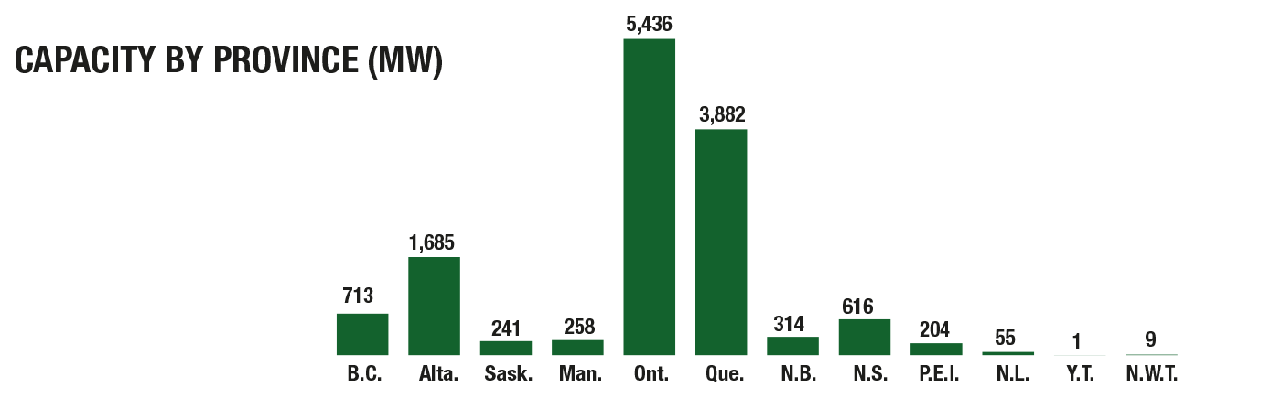
When I look at this list I think, “Yeah, Ontario!” Look how much energy you made.” They made 5436 mw where Nova Scotia created 616 mw and Prince Edward Island made 204 mw in that year. I am picturing clusters of wind turbines all over Ontario. They must be running their province on wind turbine electricity, right?
Ah, not quite.
Ontario produces 26-27 times more energy than say PEI
5436 / 204 =26.6
Ontario is bigger in landmass than PEI. I found the numbers from Google.
1,076,000 square km / 5,660 square km = 190. Ontario is 190 times bigger in landmass than say PEI (See, math classes come in handy)
BUT,
did you also know that Prince Edward Island creates 40% of it’s energy with wind turbines?
I can’t find out the % of the energy created by wind energy in Ontario. I found several sites quoting that PEI is ahead of all the other provinces in producing its energy sustainably. PEI is considered the green child of Canada’s wind turbine sector. You can read all about how PEI is planning to use wind turbines in the future here.
http://www.gov.pe.ca/photos/original/wind_energy.pdf
If you would like to know where all the wind turbines are in Canada look here.
https://open.canada.ca/data/en/dataset/79fdad93-9025-49ad-ba16-c26d718cc070
Have any of you ever seen the blade from a wind turbine on the ground? I did at the Wind Energy Institute of Canada near Tignish, PEI. They had repaired a blade to one of the massive turbines and purposely left it lying by the side of the road leading up to the Institute. I walked and walked looking at this massive blade. Probably just a good run for you young folks. Nana just refused to take her walker that far. It was 380 feet long. That is the height of a 32 story building. I don’t think we have a building that tall in Halifax or Charlottetown. Then consider they turn 10 to 20 times a MINUTE. One of them alone is a massive energy plant. The colonies of PEI produces 40% of it’s energy from wind turbines. (Yes, I am repeating myself, purposely)
The point I want to get across
You don’t have to be the biggest, the widest, or the tallest to make big things happen. You just need to be determined. You need to care about the future and dream of how we can still have things like electricity without burning fossil fuels. Maybe we need to think like “Islanders”, all islanders, to help Turtle Island, another name for this land we call Earth.
https://www.princeedwardisland.ca
these turbines are called wind farms.
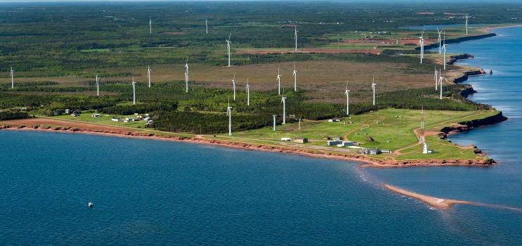
North Cape Windfarm where the Wind Energy Institute of Canada is located
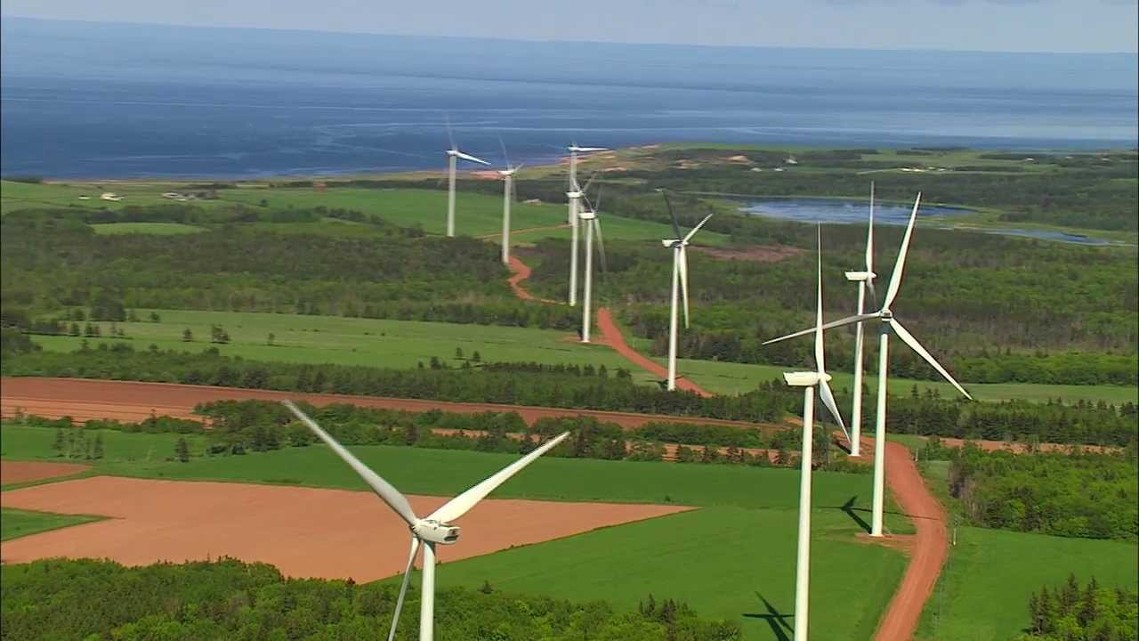
Hermanville Wind Development Turbines
A Weaving Plate
This is what I call a rainy-day craft. Weaving skills may find come up more often in adult life than you thought. This craft makes a lovely piece of art for the wall. If you are more practical, this can be used to make hot mats to put hot bowls of food on the table. I like to call it a Weaving Plate.
You will need a paper plate (foam plates tend to tear while you are weaving, double or triple if using foam plates)
String, a pair of scissors, and then material to weave with
You can use yarn or strips of cloth
Make an uneven amount of notches on the plate. Make your first notch anywhere on the plate. Make the second directly across. Then make two notches halfway between the first two. You now have 4 notches that show four quarter pieces of your plate. Make a notch at the halfway mark between each of the four notches. Then makes another notch between each of them. That is 16. You need an uneven amount so make 2 notches in one of those last spots.
Using a string, twine, or skinny yarn, and leaving a good 6 inches in back, guide your string across the plate, then behind and up in the next notch, across to the corresponding notch, and repeat. When each notch is threaded, tie your string in the back. Use that leftover six inches of string to secure your beginning notch in the back. Take another short piece of string and tie about where the middle is on the front of the plate. Use the tail end of that string to start your weaving in and out of each spoke of the wheel. Start tying yarn or material to that piece of string and then add the next to where your yarn ends. Weave in and out as tight to the center as you can.
To use as a picture, simply put a picture hook on the back, hot glue a pushpin on the back, or tape a piece of string that can be hung over a pin put in the wall.
To use as a hot mat, weave tightly up to the edge of the plate. If you have a crochet hook, simply cut the spoke strings one by one at the middle of the back, and weave or hook the string into the back a few times before cutting off. Makes a nice useful hot mat.
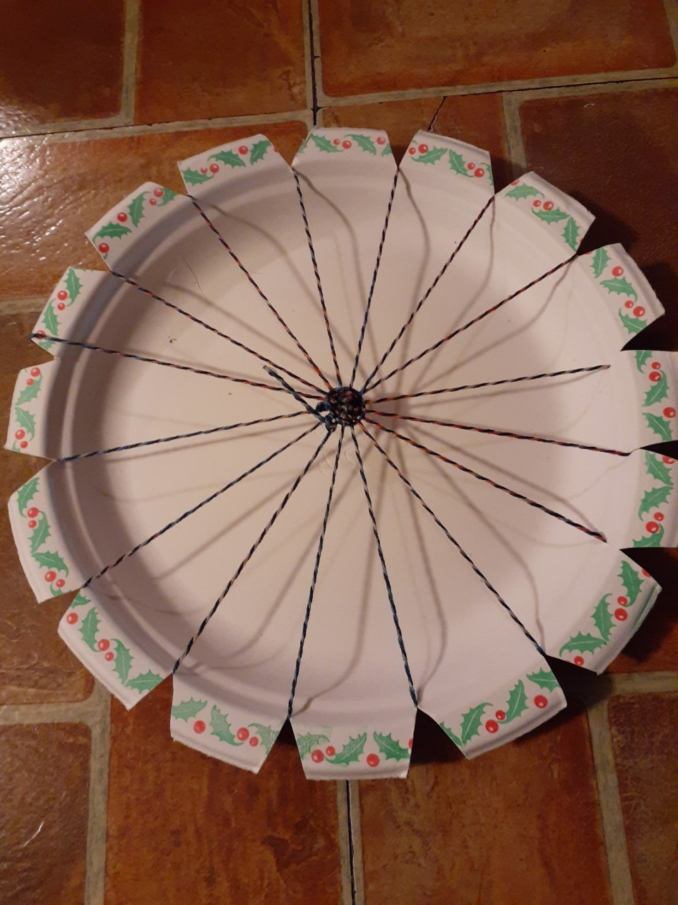 | 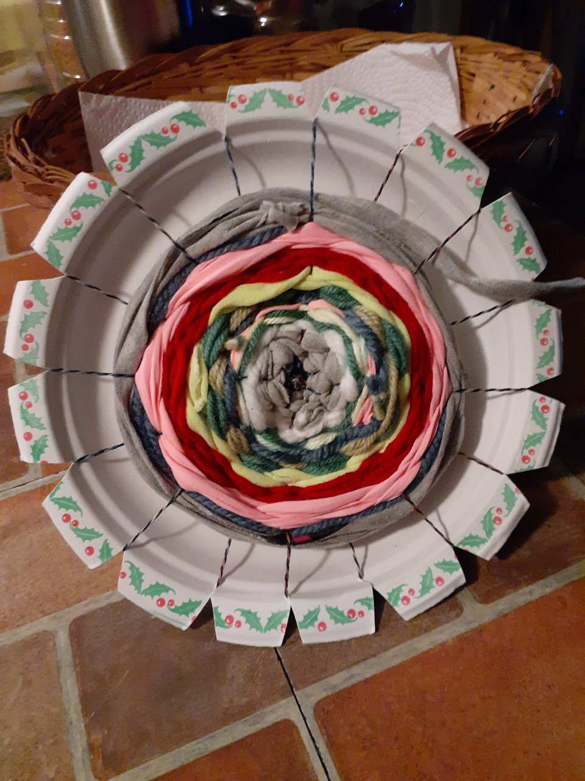

Something to eat
When I was a teenager I often took “Pigs in a Blanket” to my AYPA meetings. Remember AYPA? (Anglican Young People’s Association) We met Friday nights. There was a meeting where we teens were talked into service work and planned where and what we wanted to do. We had bottle drives and bake sales to raise funds so the adults could take us off to tour industries, go bowling “in the city” or maybe visit another AYPA group, etc. The evening always had lunch and then a sock hop. We danced till that old hall was hoping. At 9 PM we all groaned when the lights flickered to tell us it was the last dance. No one was on the sidelines for that song. It doesn’t seem like a bad idea for this day and age. Hummmm…….
Pigs in a Blanket
Originally they were sausages, what we use to call Halifax sausages, small ones compared to the large Lunenburg sausages we usually ate. These had been fried and drained. A batch of baking powder biscuits was mixed up and rolled out. The sausages were tucked in a piece of biscuit and baked in the oven
2021 Pigs in a Blanket
You need
Hot Dogs
Puff Pastry
Cheese slice
Spread out the puff pastry
Place a cheese slice on top
Place the hot dog on top and roll it together
Cut in 4 pieces. Repeat putting pieces on a baking sheet
Bake 350F for 12-15 minutes.

Till next week, wishing you a good one. Grandma’s sending hugs
caz@grandmasgoinggreen.com

New hymn for the Season of Creation and to prepare for COP-26
1 O God of boundless hope,
we need your Spirit’s power;
creation’s crisis deepens with
each passing hour.
So make us strong
to speak your word,
and make it heard,
and right what’s wrong.

2 Too many suffer now
from fire and wind and rain,
as livelihoods and homes are lost
and hope seems vain.
Will we ignore
all those who strive
just to survive,
and close our door?

3 The world is changing fast
and warming year by year;
a tipping point is close,
the time to act is here.
We’ll work and pray;
as nature bleeds
we’ll sow the seeds
of hope today.

4 Together we will walk
the new way you reveal;
our planet cries from wounds ‘
that love alone can heal.
Inspire us, Lord,
to give and care,
that all may share
your earth restored.
Author: Brian Davis
Tune: DARWALL’S 148TH
https://www.jubilate.co.uk/songs/o-god-of-boundless-hope

