The Casa del Sol Blessings of Jesus

Blessed are those who know their need
for theirs is the grace of heaven.
Blessed are those who weep
for their tears will be wiped away.
Blessed are the humble
for they are close to the sacred earth.
Blessed are those who hunger for earth’s oneness
for they will be satisfied.
Blessed are the forgiving
for they are free.
Blessed are the clear in heart
for they see the Living Presence.
Blessed are the peacemakers
for they are born of God.

From John Philip Newell, Praying With the Earth (Eerdmans: Michigan). Based on Matthew 5:3-9

A Liturgy for
The Season of Creation
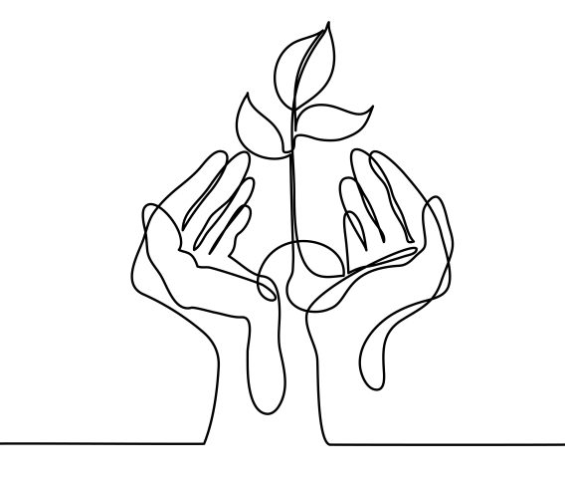

The Parish of Wilmot, Diocese of N.S. and P.E.I

Liturgy for the Season of Creation
Texts taken from The Anglican Church of South Africa, The Anglican Church of New Zealand, thepastorsworkshop.com, and The Anglican church of Canada

Processional Hymn

Opening Response
O Divine Voice – You sing and the universe comes into being.
O Divine Breath – You breathe and all things spring to life
O Divine Word – You call and creation is sustained
O Divine Flesh – you are born among us
O Divine Spirit - you fill all that has been formed
O Divine Life – you are the pulse of all that is
And so, in amazement, awe, wonder, and celebration
We marvel at this mystery
In you, all things live and move and have being
In all things, you live and move and express your Divine artistry
And so, we join with creation in the eternal song of worship and wonder…

Song of the Three (music can be found in Common Praise # 754)
Praise God and highly exalt God for ever.
Glorify the Lord, all you works of the Lord,
praise God and highly exalt God for ever
In the firmament of God’s power, glorify the Lord
praise God and highly exalt God for ever.
Glorify the Lord, O mountains and hills
praise God and highly exalt God for ever.
O springs of water, seas, and streams,
praise God and highly exalt God for ever.
O whales and all that move in the waters.
praise God and highly exalt God for ever.

Breaking of Bread

Creator of all, You gave us golden fields of wheat whose many grains we have gathered and made into this one bread. So may all creation be gathered from the ends of the earth into your kingdom.

Sharing of Communion

Hymn During Communion

Prayer After Communion
O God, You have blessed us, and fed us with your Body and Blood – your very life force. You have come close to us and we have come close to you in this precious feast, where Heaven and earth meet.
And so, with all the realm of Nature – the growing and creeping things; the running and leaping things; the flying and the swimming things, we proclaim your glory which reaches to the heavens - holding all in sovereign love and care. In company with all created things, we sing the joy, the beauty and the glory that is Creation’s song. Amen
Blessing
May God, who established the dance of creation, marvelled at the lilies of the field, and transformed chaos to order, lead us to live in interconnected relationship with all creation. And may the blessing of God, Source of All being, Eternal Word and Holy Spirit, be with you now and always. Amen
Announcements
Recessional Hymn
Dismissal
,

As we look for Christ’s second coming,
reconcile us to our world
and give us the broken oneness, the split unity
and the buried resurrection
by which we can restore your creation and fulfill your will.
Send upon us and all your creation,
the life-giving Spirit who first moved upon the waters of the deep.
Stir in us the creative and redeem the destructive.
Unite us with you through the body and blood of your Son,
by whom and with whom and in whom,
in the unity of your Creative Spirit.
With all that has been, is and will be in your universe,
we stand before you and worship you,
God of all, in songs of everlasting praise. Amen

Lord’s Prayer Alternative version from Church of New Zealand
Eternal Spirit, Earth-maker, Pain-bearer, Life-giver,
Source of all that is and that shall be,
Father and Mother of us all,
Loving God, in whom is heaven:
The hallowing of your name echo through the universe!
The way of your justice be followed by the peoples of the world!
Your heavenly will be done by all created beings!
Your commonwealth of peace and freedom sustain our hope and come on earth.
With the bread we need for today, feed us.
In the hurts we absorb from one another, forgive us.
In times of temptation and test, strengthen us.
From trials too great to endure, spare us.
From the grip of all that is evil, free us.
For you reign in the glory of the power that is love, now and for ever.
Amen.

Let the earth glorify the Lord
praise God and highly exalt God for ever.
praise God and highly exalt God for ever.

Collect (see insert)

Proclamation of the Word (see insert)
First Reading, Psalm, Second Reading, Gradual Hymn, Gospel, Sermon

A Statement of Trust and Commitment

O God, source of all being, goal of our longing,
we believe and trust in you.
The whole earth is alive with your glory,
and all that has life is sustained by you.
We commit ourselves to cherish your world,
and to seek your face.
O God, embodied in a human life, we believe and trust in you.
Jesus, our brother, born of the woman Mary,
you confronted the proud and powerful,
and welcomes as your friend those of no account.
You laboured with us upon the cross
and have brought us forth to the hope of resurrection.
We commit ourselves to struggle against evil,
and to choose life.
O God, life-giving Spirit of healing, comfort, integrity and truth,
we believe and trust in you.
Warm-winged Spirit, brooding over creation,
rushing wind and Pentecostal fire,
we commit ourselves to work with you in renewing our world.

Prayers of the People

Prayer of Confession

Shepherd of Israel, God of hosts,
we have turned away from you,
neglecting the welfare of your creation,
ignoring the plight of your people,
trampling on the creatures and the plants you have made,
taking from Earth what we cannot give back.
We have not helped our neighbors in need,
kept peace within our families,
or tended the vine you planted in our lives.
Forgive us and lead us to a more gracious life.
In your compassion, turn us to your way.
Restore us, O Lord God of hosts;
let your face shine upon us, that we may be saved. Amen.

Absolution
May the God of love forgive and strengthen you to live in harmony with all creation.
May the Spirit of Love fill your life to overflowing,
And may you walk, this day and always, in the footsteps of Christ. Amen
.

Sharing of the Peace

Offertory Hymn

Prayer Over the Gifts (see insert)

Eucharistic Prayer

The Lord is here. God’s spirit is with us
Lift up your hearts. We lift them up to God
Let us give thanks to the Lord, God of all Creation
It is right to give our thanks and praise

Eternal One,
you spoke the word and all that is in heaven and earth came to be
Your Spirit hovered over the primal elements,
and you brought forth life in forms innumerable,
including this our fragile earth and us among its inhabitants.
as our past is in you, so our hope for the future rests with you.
As we have turned away from your way,
so we turn again to the warmth of your love.
Through you all things are brought to new life.
And so, with the wonders of creation
and the songs of praise of all your creatures in heaven and on earth,
we praise you now, saying :

Holy, holy, holy Lord. God of power and might, heaven and earth are full of your glory. Hosanna in the highest. Blessed is the One who comes in the name of the Lord. Hosanna in the highest.

In the night that Jesus was betrayed,
he took bread, work of human hands, gift of our earth
and gave thanks to God,
he broke the bread, gave it to his friends and said,
“Take and eat, this is my body which is given for you,
do this in remembrance of me”
He took the wine, work of human hands, gift of our earth
and gave thanks to God.
He gave it to his friends saying,
“This is my blood of the new covenant shed for you
and for all creation for the forgiveness of sins.
Every time you drink of the wine,
do this in remembrance of me.”
So we proclaim the mystery of faith:

Christ has died, Christ is risen, Christ will come again.

Therefore God,
we who desire reconciliation with you,
with one another and with all creation,
draw close to this mystery.

