September 14, 2021
Email: endionspei@gmail.com Website: nspeidiocese.ca/den
Facebook: Environment Network Diocese of NS & PEI
Welcome to our weekly Enews.
The Diocesan Environment Network (DEN) of the Anglican Diocese of NS & PEI, was formed in response to the Fifth Mark of Mission and the latest addition to our Baptismal Covenant which has become our Mission Statement.
“To strive to safeguard the integrity of creation and sustain and renew the life of the earth.”
To do this we educate and encourage stewardship through social media and liturgies, connect with other environment groups, pray together, celebrate art with each other and grieve together.



Thursday Night DEN Gatherings have resumed. Join us Sept 16th at 7 pm. Action by Churches Together (ACT) and COP 26 Glasgow Simon Chambers
Simon Chambers currently serves as Director of Communications with the Action by Churches Together (ACT) Alliance. ACT is a global network of 140 churches and church-based agencies engaged in humanitarian, development and advocacy work in over 125 countries. Part of ACT’s work involves climate justice, including a presence at the UNFCCC’s Conference of the Parties each year. Prior to working with ACT, Simon was communications coordinator at the Primate’s World Relief and Development Fund, and also worked for PWRDF facilitating their youth programme. His background includes over 20 years of youth ministry in the Anglican Church from the parish to the international level. Simon has attended the last three COPs with ACT Alliance, and will be present in Glasgow for COP26, working with ACT and other ecumenical and interfaith groups to raise the voices of the most vulnerable people in the world and to fight for urgent, ambitious, and equitable climate action by all the nations of the world. A blurb: COP26 represents a vital opportunity for the world to come together and increase our ambition and commitments to combat climate change and limit global temperature rise. People of faith around the world are raising their voices, demanding climate justice, supporting the most vulnerable, and living into our baptismal covenant as we work as stewards of creation. In this session, Simon Chambers from ACT Alliance will talk about the issues that will be on the agenda at COP26, and also about how people of faith can engage in advocacy, follow the events at COP, and join the global ecumenical movement for climate justice

For more information Email endionspei@gail.com
Join Zoom Meeting: https://us06web.zoom.us/j/87171326550

Green Cents – Save the Date DEN will be sponsoring a ZOOM Symposium on Nov. 18th at 7 pm. Green cents is about people, liturgical practices and site management. More details to follow soon!

On September 15th, Greenpeace turns 50! To celebrate these achievements and chart the course for many more to come, join them on September 15th:

- Greenpeace International will host a Zoom call with Greenpeace’s founders and allies on September 15th, 12pm EST

- You can take a virtual tour of the Greenpeace ship Rainbow Warrior on September 15th, 11am EST

- Greenpeace Canada will be going "live" on Facebook on September 15th, 2pm EST

They will be reacting to some of our favourite memories supporters like you share with them, reflecting on the roles Greenpeace has played over the last fifty years, and sharing visions of where the movement for social and environmental justice is going! Share your favourite memory with them here. https://greenpeacecanada.typeform.com/to/JzgVqWe6

NSCC Program – Coastal Protection Environmental Technologies (view details on program page) October 12, 2021
Location: Strait Area Campus, Port Hawkesbury & field camp component on Bras d’Or Lake
Program length: 7 weeks
Admission requirements: Diploma or undergraduate degree in geography, engineering, or marine technologies; or an undergraduate degree in natural or social sciences.
Credential: Certificate of Professional Studies
Tuition: $2,000. View full program fees.
*Bursary value: $2,185. View funding details.
Learn more: Webinar and live Q&A on September 15th from 6:00-6:45pm ADT. Register here.
*Indigenous peoples are automatically considered for additional funds of up to $300/week to help with living expenses while enrolled. To apply, please visit the program page.


Christians around the world are invited to give particular attention to praying for and caring for God’s Creation as part of the global Season of Creation observed from September 1 to October 4 every year. The theme this year is “A Home for All”. For more information, check out the DEN webpage: https://www.nspeidiocese.ca/pages/den-season-of-creation--288
Please tell us what your parish is doing. Email your story and photos to endionspei@gmail.com

Palm Oil The only place on Earth where orangutans, elephants, rhinos, and tigers live together is being ripped to shreds to make way for palm oil. By sourcing from Royal Golden Eagle (RGE) -- one of the world’s most notorious forest-destroyers --the maker of Oreos, Ritz and Cadbury is knowingly buying up the palm oil that’s killing this precious ecosystem.
petition to save ecosytem
We Need the Amazon It may be far away from us, but we need the Amazon. Not just because it provides us with the water we drink and the air we breathe... Not just because it’s a treasure of biodiversity... Not only because so many people and communities depend on it...We need to keep the Amazon (and all forests) standing because it’s our best chance of stopping runaway climate chaos — forests are the world’s best natural carbon storage. That’s why these fires are so scary: They’re releasing tons of carbon into the atmosphere every day they’re burning.
petition to banks financing rainforest destruction
Save Life on Earth This petition is written by a leader of more than 500 Indigenous nations across the Amazon. It is asking for your support and calling on us to meet existing targets, to protect biodiversity, to ensure at least 50% of lands and oceans are protected and restored, and to ensure that our planet is completely sustainably managed. There is no doubt that we MUST protect the forests, rivers, and oceans that sustain us all, from the Amazon to Africa and Indonesia all the way to Canada. Our survival depends on it and if everyone took a stand then we could make a change.
Avaaz petition to save life on earth

Stop Export of Thermal Coal It’s time for Canada to stop carving up mountains, polluting the air, and making the climate emergency even worse by mining thermal coal and shipping it overseas. Canada has brought in regulations to stop burning it for electricity by 2030, yet we are continuing to export thermal coal to be burned in other parts of the world. We all live on one planet and environmental harm harms us all no matter where one part of a problem ends up. This petition is asking us to send a letter to Minister Wilkinson and call for an end to thermal coal in Canada.
Ecojustice petition to end thermal coal
“They paved Paradise and Put up a Parking lot” All around our country different communities are trying to save their forests from being destroyed. This 4-acre red pine forest near Ottawa is called Hunt Club Forest, and it is only 5 years away from being classified as “mature forest”. It provides a refuge for community members and a home for the many animals that live in it. The plan is to cut it down and build a parking lot. We can add our voices in saying our forests are worth protecting.
Petition to save Hunt Club Forest in Ottawa
The future of the world’s forests depend on the communities who protect them and call them home. However, as forests are destroyed for oil palm and pulp and paper plantations, the rights of Indigenous and frontline communities are being ignored. Major brands and banks, including Nestle, source from the forestry and agribusiness giants that are responsible for the violation of human rights, and exploitation of lands that are traditionally-owned by Indigenous and local communities. According to the United Nations Declaration on the Rights of Indigenous Peoples, they have the right to say “no” to unwanted development on their land. This right, however, has been too long ignored by producer company’s eager to expand their plantation holdings. https://act.ran.org/page/23251/action/1?ea.tracking.id=e_en&en_og_source=e_en&utm_medium=Email&utm_source=EngagingNetworks&utm_campaign=fundraising&utm_content=Email+2&ea.url.id=857559&forwarded=true
Tree Houses
I am always looking for a green story. It doesn’t have to be big or forefront in the news. It just has to be something that helps the environment or even shows off a different environment.
The word environment does not only mean all the R’s, or a big project. Environment means what are the physical aspects of ANY space. We could talk about the environment inside a library: the layout of chairs, the air quality, how we usually are a bit quieter there or if they have inside plants. All these things make up how people see a particular space or what the environment is like there.
Look for spaces that help the planet and you will find green stories. Grandma just wants you to know such places exist.
This week we are looking at tree houses.
First, I have a picture of a House for trees. It was hard to find the best one that would show you the difference in the “environment” of these two buildings and the rest of the buildings around them. This video shows it off
https://www.stefanoboeriarchitetti.net/en/project/vertical-forest/#wp-video-lightbox/-1/
These two towers hold 800 trees, 5000 shrubs, and 15,000 plants. It is considered a “home for trees that also houses humans and birds”. It absorbs 30 tons of CO2 each year, filters out dust, reduces noise, and even helps to moderate the temperature with the seasons
There are many plant-covered houses around the world. Look at a few more with this link
https://www.fodors.com/news/photos/10-plant-covered-buildings-around-the-world
Then there are treehouses, not the type that kids may want for their fort but real livable spaces.
The modern tiny treehouse
https://www.youtube.com/watch?v=WGaICSbCr1c
Tree Houses in Miramichi, New Brunswick for rent
https://www.campingmiramichi.com/
The image of the treehouse on the right came from
https://www.google.ca/imgres?imgurl=https%3A%2F%2Fcdn.wallpapersafari.com%2F17%2F95%2F1P0MCS.jpg&imgrefurl=https%3A%2F%2Fwallpapersafari.com%2Fw%2F1P0MCS&tbnid=x-XNiwC0P_k0IM&vet=10CBgQxiAoBmoXChMI2Peq_Z3v8gIVAAAAAB0AAAAAEAI..i&docid=U5Bjs2ZR_OarlM&w=500&h=500&itg=1&q=Tree%20Houses%20in%20Canada&ved=0CBgQxiAoBmoXChMI2Peq_Z3v8gIVAAAAAB0AAAAAEAI
Yes, it is a long link but always give credit to someone else’s work. I wonder how someone got in the right place to even take these pictures.
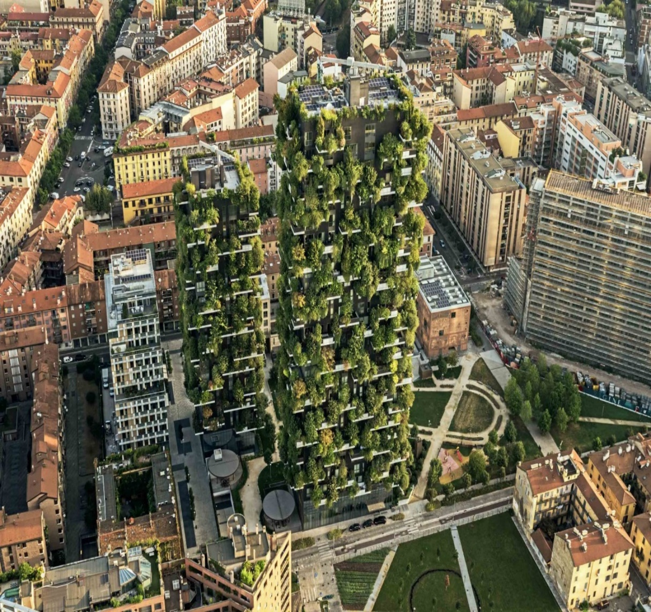 | 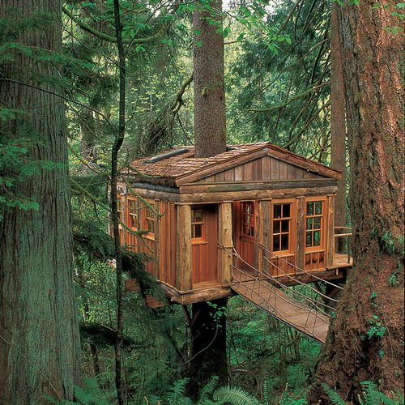

Crafts
Soon I will show you how to make log houses with paper tubes. You might want to save the middles of paper towels, aluminum foil, wax paper, plastic wrap, etc.
This week I want to show you tin can lanterns
You will need a clean tin can minus the paper covering, water, a hammer, a nail, an electric tea light, a towel, and a bit of wire for the handle.
Clean your can, fill it with water and put it in the freezer for a day or two
When ready, find a towel and fold it to make a little bed for the tin can to lay in
First, with a nail and hammer, punch two holes at the top of the can directly across from each other. You will attach the handle here
Next, punch holes all over the can. If the can had rims or edges going down the side, try to punch in lines. Some people draw a picture and punch out the outline. No matter what, if your tin can has holes punched in it, the lantern will work.
Take the can outsides in summer or place it upside down in a sink and let the ice melt out.
Sometimes I paint the cans at this stage.
Using a piece of rabbit wire or even floral wire fashion a handle through the two holes at the top.
Grandma uses a bit of 2-way tape to hold her electric tea light in place.
They light up beautifully after dark. Have fun putting them in the dark and seeing the pattern of your holes.
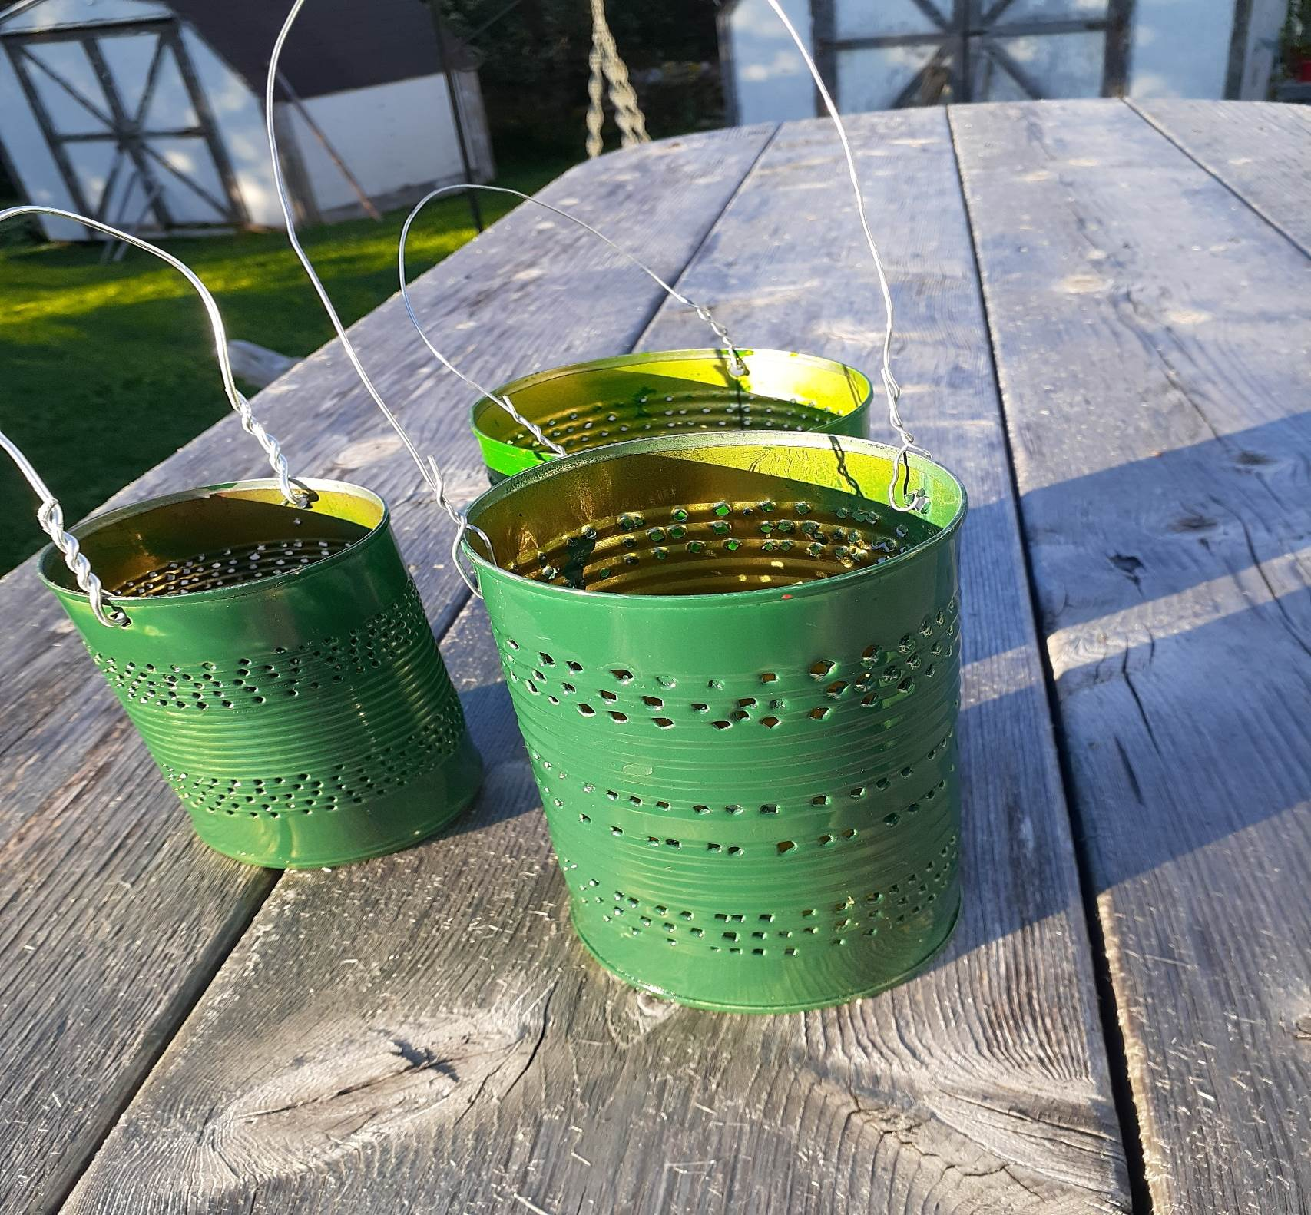
Something to eat
Grandma knows it is very early to think anything about the December holidays; however, it wouldn’t hurt to practice a nice gift from the kitchen now and then tuck it away till December. We are talking about trees this week. I like to make Brownie trees for holidays or simply whenever I need to put out a sweet at an event
I am giving you my Brownie recipe but also giving you a webpage to show you how to make the trees
https://onelittleproject.com/christmas-tree-brownies/
You need a pan of Brownies, candy canes (use popsicle sticks cut in half during summer), and green icing. I like the way they taught us how to make an icing decorator from a sandwich bag. The tiniest hole in a corner of the bag allowed to squeeze a line of icing out. REPURPOSING
See what you think about this baking craft.
Brownies
In one bowl mix
2 cups flour
1 cup sugar
½ cup cocoa
½ tsp baking powder (we don’t want them to rise too high to make trees)
Mix and make a well in the middle. Add
2 eggs
1 tsp vanilla
A bit of milk (or water)to make a goosy mixture
Bake in an 8-inch pan at 350F for 20-25 minutes
Take out of the pan after 5 minutes and let cool before doing the craft
(Hint: Little brothers, sisters, and even Dads like the leftover corners.
Have fun

Canterbury Cathedral
·
The Archbishop of Canterbury, the Pope, and the Ecumenical Patriarch have issued a joint call for prayer and practical action for the environment, as world leaders prepare for the COP26 Climate Summit. We join with them in praying for our earth and for ourselves as we seek to live in ways that are more sustainable.
Lord of all,
you created the earth to be our home,
and charged us to cultivate it and care for it.
Give us in our own day
the wisdom to know what is good for our planet,
the restraint to work with the earth in ways that are sustainable,
and the forethought to preserve the beauty of our environment
for future generations,
through Jesus Christ our Lord. Amen.

