August 31, 2021
Email: endionspei@gmail.com Website: nspeidiocese.ca/den
Facebook: Environment Network Diocese of NS & PEI
Welcome to our weekly Enews. The Diocesan Environment Network (DEN) of the Anglican Diocese of NS & PEI, was formed in response to the Fifth Mark of Mission and the latest addition to our Baptismal Covenant which has become our Mission Statement.
“To strive to safeguard the integrity of creation and sustain and renew the life of the earth.”
To do this we educate and encourage stewardship through social media and liturgies, connect with other environment groups, pray together, celebrate art with each other and grieve together.



Many thanks to Nancy Blair, one of DEN’s Coordinators, for planning a wonderful slate of guest speakers for our Fall 2021 weekly Zoom sessions; Thursday evenings at 7 pm. Please join us for enlightening speakers and conversation around the topic. Mark your calendar for these sessions in September:

September 9, Ron Colman, CPI Atlantic -:” What Really Counts” - his new book.
September 16, Simon Chambers, ACT - COP26 Glasgow
September 23, Suvir Singh, Climate Emergency Task Force (CCTF) operating in CP
September 30, Krista Phillips, NS Dept. Mines and Energy, Electric Ferries and Other Trends in Energy and Clean Transportation

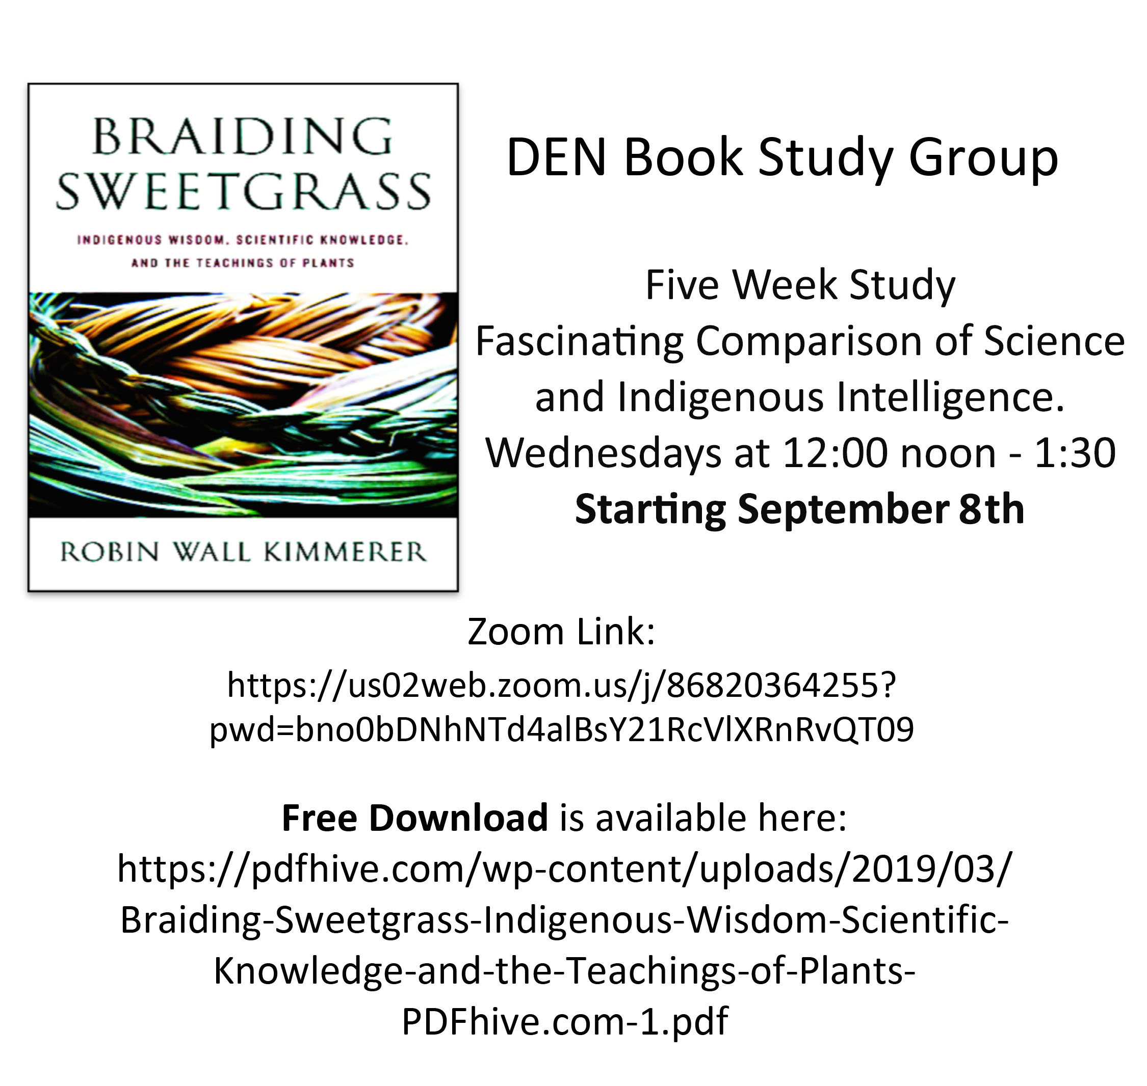


Christians around the world are invited to give particular attention to praying for and caring for God’s Creation as part of the global Season of Creation observed from September 1 to October 4 every year. The theme this year is “A Home for All”. For more information, check out the DEN webpage: https://www.nspeidiocese.ca/pages/den-season-of-creation--288
Or email endionspei@gmail.com


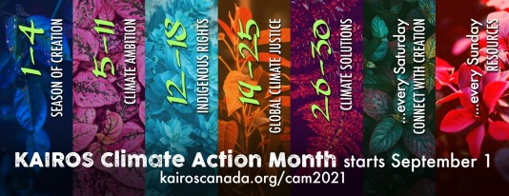
Climate Action Month Starts September 1st
**To receive updates on Climate Action Month, subscribe to the KAIROS e-newsletter and select Ecological Justice as an area of interest.**

Climate Action Month (CAM) falls as the world continues to grapple with the COVID-19 pandemic and recovery; as the Intergovernmental Panel on Climate Change releases yet another dire warning for the planet; as calls for truth and reconciliation reach new levels of urgency in Canada; and as Canadians prepare for a federal election. Let's take action together this September!
Each day in September, KAIROS will share information on a topic related to climate change, with the goal of motivating and inspiring a daily practice of taking action for the climate. The month will be centered around weekly themes, with supporting resources for each, including reports, videos, theological reflection, events and more. We will highlight the work of KAIROS member churches, feature stories from global partners, and showcase communities that are taking concrete steps to address the climate emergency. Read more in the Overview of CAM.
Every Friday, we will feature actions related to the weekly themes and every Saturday we invite folks to make space to connect with Creation in whatever way is accessible and available to you. We will provide some resources for contemplation as an option to guide those moments of connection.
Weekly themes:
- Sept 1-4: Season of Creation
- Sept 5-11: Climate Ambition and Just Transition
- Sept 12-18: Indigenous Rights
- Sept 19-25: Global Climate Justice
- Sept 26-30: Climate Solutions
Key dates and events:
- Sept 1: World Day of Prayer for Creation
- Sept 9, 16, and 23: For the Love of Creation Advocacy Webinar Series on climate finance, Indigenous rights, and climate ambition and transition - 7 pm EDT REGISTER NOW!
- Sept 14: Local Climate Action: Successes, Struggles and Hope for the Work Ahead - 7-9 pm EDT REGISTER NOW!
- Sept 24: Global Climate Strike
- Sept 30: Orange Shirt Day/National Day for Truth and Reconciliation
Season of Creation:
During Climate Action Month, we also mark the Season of Creation, which runs from September 1 - October 4 (St. Francis of Assisi Day). We will highlight the Season of Creation in Week 1 – marking the World Day of Prayer for Creation on September 1 and celebrating the ecumenical work of For the Love of Creation.

This federal election will be pivotal in determining the future we want for our families, communities, and planet. We are facing a climate and biodiversity crisis and it's time our decision makers acted like it. This letter will go to federal party leaders and local candidates.

Tell leaders youre voting environment
As you know, RBC is the biggest financier of fossil fuel companies in Canada. Stand.earth have asked us to keep the pressure on RBC’s CEO by sending him an email urging him to watch powerful video messages, and to do the right thing and stop banking on climate destruction.

Tell RBC to stop financing fossil fuels.
At a 7.5 million dollar price tag, Line 3 would be one of the largest crude oil pipelines in the world. Which means that 915,000 barrels of tar sands crude, some of the Earth's dirtiest oil, would traverse delicate wetlands, rice beds, and lakes daily. Violating Ojibwe treaty territory, Line 3 would put First Nation communities and our environment at risk https://www.thepetitionsite.com/takeaction/188/947/390/?z00m=32807851&redirectID=3140904487
In the U.K. up to 0.15% of plastic is allowed to go into feed for animals destined for human consumption. https://www.thepetitionsite.com/107/005/038/?z00m=32833413&redirectID=3140904986
Food Waste
Grandma wants to talk a bit about food waste. It seems strange to me that there is a problem centered around food waste when there are people going hungry. I don’t mean food waste that is a piece of bread that goes dry and is given to the birds. Sometimes a cucumber gets forgotten until even a cuke salad can’t save it. These are the exceptions, not a norm. Let’s call this business food waste until we find a better title.
In Canada more than half of all food produced is lost or wasted according to the CBC.
Why does that happen? A lot of waste has to do with the veggie or fruit not looking quite as pretty, as the ones found in the grocery store. They have the same calorie and nutritional count but maybe that watermelon has marks on it or is more oval than round shape. It wouldn’t bother Grandma if the fruit or veggie wasn’t a perfect shape, but it does bother a lot of people.
Someone from Caribe Fruit noticed watermelon fields where a lot of fruit was left to rot and be plowed back into the ground. That disturbed them enough to start a new business. It is a company that bottles cold pressed watermelon water (WTR MLN WTR) as a health drink. The singer Beyonce along with other celebrities have endorsed the product.
Food that would have gone to waste was re-routed to a plant that turns it into a flavored water. First this prevents the waste of food. Next it makes jobs for a rural area and gives us a healthy product to consume. It’s a win all way around.
I remember reading before the pandemic where a company near Halifax took left over cauliflower from the fields and turned it into a flour. Anyone know of a company near them that is saving food from waste?
It is almost REPURPOSE because something new or different from the usual way we eat a food like watermelon was created. It’s still watermelon and humans still consume it so is it a REPURPOSE? That would make a good debate.
Debates are fun. You pick one side of an argument and try to convince people that your idea is the correct one. A lot of knowledge is taken in by both the debaters and their audience. Sometimes, my teacher would assign the opposite point of view to my interest for me to debate. I disliked it but it did teach me tolerance of other’s views.
As usual I have a few references for you
CBC article on food waste
https://www.cbc.ca/news/canada/toronto/food-waste-report-second-harvest-1.4981728
Caribe WTR WML WTR
https://www.foodbev.com/news/caribe-juice-acquires-cold-pressed-juice-peer-wtrmln-wtr/
Food waste is the world’s dumbest problem
https://www.youtube.com/watch?v=6RlxySFrkIM
Businesses fighting food waste
https://www.fastcompany.com/90337075/inside-the-booming-business-of-fighting-food-waste
How businesses reduce their waste
https://www.cbc.ca/news/canada/toronto/waste-plastic-food-compost-recycling-coffeecup-1.4961433
A soup kitchen using food grown in community gardens
https://www.cbc.ca/news/canada/windsor/soup-rescue-program-serves-up-1.4936539
Sending Food North where a bag of peppers could cost $40 says a friend living there. This is sent to Food Distribution Centers free
https://www.cbc.ca/news/canada/windsor/swo-gleaners-leamington-erb-group-rfda-thunder-bay-1.4931308

Coffee Cup Planter
This week’s craft is easy and fun
You need a paper coffee cup, a pair of scissors and some twine, string, yarn or jute.
Ask Mom or Dad to save the coffee cup next time they visit their coffee shop. Give it a wash and dry.
Cut the cup from top to the rim around the bottom into an uneven number of pieces.
Bend these pieces back so what was the outside of the cup is now the inside.
Start weaving your string in and out of the strips of paper
The top is a little tricky. Most cups have a rolled top. You should be able to thread a darning needle and sew the top together through these holes in the rim of the cups. The green cup I folded the top back and sewed each top together. I am not happy with the top yet. How would you finish it off?
You can add potting soil and a plant to sit indoors or as a gift to someone down the street or in a nursing home.
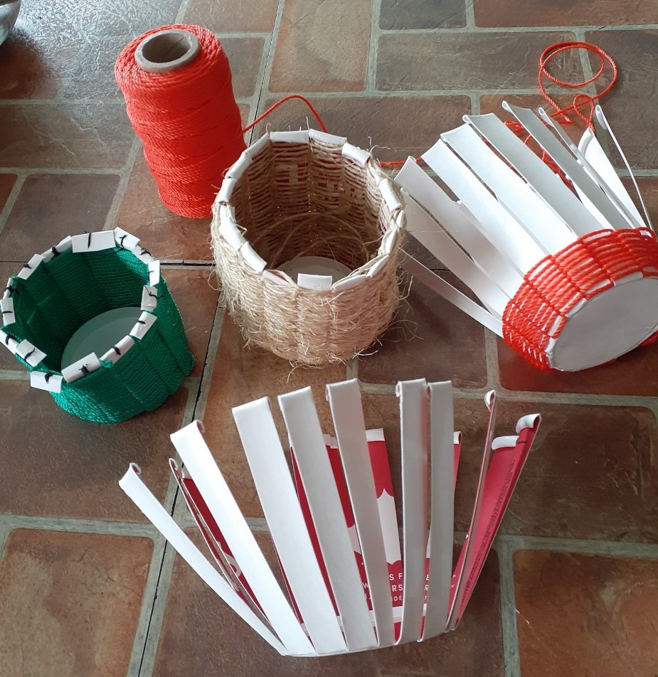

SOMETHING TO EAT
Since I mentioned a cucumber salad earlier, let me tell you how I make mine.
I prefer to use field cucumbers, however, it can be made with an English cucumber that was starting to get soft
Deutsch Salad
Cucumbers
Onions
Salt
Mayonnaise
Peel cucumbers and onions and slice them thin
Place alternate layers of onions and cucumber slices in a bowl with a sprinkle of salt
Place a smaller bowl holding a heavy weighted object on top of mixture and leave overnight to press out excess water
Before using next day, drain off the water and add mayonnaise, mix and serve
You can get fancier and make your own mayonnaise, but plain store-bought type still tastes good.

We Hold the Earth
We hold brothers and sisters who suffer from storms and droughts intensified by climate change.
We hold all species that suffer.
We hold world leaders delegated to make decisions for life.
We pray that the web of life may be mended through courageous actions to limit carbon emissions.
We pray for right actions for adaptation and mitigation to help our already suffering earth community.
We pray that love and wisdom might inspire my actions and our actions as communities. . .
so that we may, with integrity, look into the eyes of brothers and sisters and all beings and truthfully
say, we are doing our part to care for them and the future of the children.
May love transform us and our world with new steps toward life
https://www.faithclimateactionweek.org/prayers-and-climate-blessings/

