August 10, 2021
Email: endionspei@gmail.com Website: nspeidiocese.ca/den
Facebook: Environment Network Diocese of NS & PEI
Welcome to our weekly Enews. The Diocesan Environment Network (DEN) of the Anglican Diocese of NS & PEI, was formed in response to the Fifth Mark of Mission and the latest addition to our Baptismal Covenant which has become our Mission Statement.
“To strive to safeguard the integrity of creation and sustain and renew the life of the earth.”
To do this we educate and encourage stewardship through social media and liturgies, connect with other environment groups, pray together, celebrate art with each other and grieve together.


Christians around the world are invited to give particular attention to praying for and caring for God’s Creation as part of the global Season of Creation observed from September 1 to October 4 every year. The theme this year is “A Home for All”. For more information, check out the DEN webpage: https://www.nspeidiocese.ca/pages/den-season-of-creation--288
Or email endionspei@gmail.com


IPCC ( Intergovernmental Panel on Climate Change ) - latest climate change report released Aug. 9th. https://www.ipcc.ch/2021/08/09/ar6-wg1-20210809-pr/

The Nova Scotia Environment Network Is hosting a coffee House – August 12th
https://www.facebook.com/events/1046554032549136/?ti=ls

A Message from Kairos Seeking volunteers... I hope many of you are familiar with the national faith-based initiative for climate justice, For the Love of Creation (FLC, https://fortheloveofcreation.ca/) FLC is holding an online fall symposium on Saturday, October 30th from 12am to 6pm Atlantic time.
We are looking for at least one, if not more, "local connectors" to represent each of PEI and Nova Scotia. Can you help?
People from across Canada will facilitate some small networking groups during the symposium. These local connectors would lead a 30 minute small group discussion with others from their region. The purpose of these small groups is to network with others in your area and begin a discussion about the best ways to address the climate crisis in your area, as people of faith. You at DEN are already connected across the region, but it would be an opportunity to strengthen your ecumenical and possibly inter-faith connections.
If you are willing to volunteer in this role representing your city or province, please contact me, Shannon, by email at sneufeldt@kairoscanada.org.
Shannon sneufeldt@kairoscanada.org
Say Yes! to Kids Interested in having your parish possibly benefit from the funds raised. Go on the Anglican Foundation website – www.anglicanfoundation.org to see the comprehensive Request-For-Proposal package. Under the heading Apply – click on 2021 Request-For-Proposal. Contact us here if you are interested in preparing a proposal. The Diocese has a team that reviews AFC grant proposals to help ensure they check all the boxes and are definitely interested in having our Diocese benefit from Say Yes! to Kids funds. DEN will put you in touch with the right people.
We are very happy to introduce you to Stella Lord who you will know well from her participation in our weekly Zoom Meetings. Here is a chance to know even more about her and her passions.

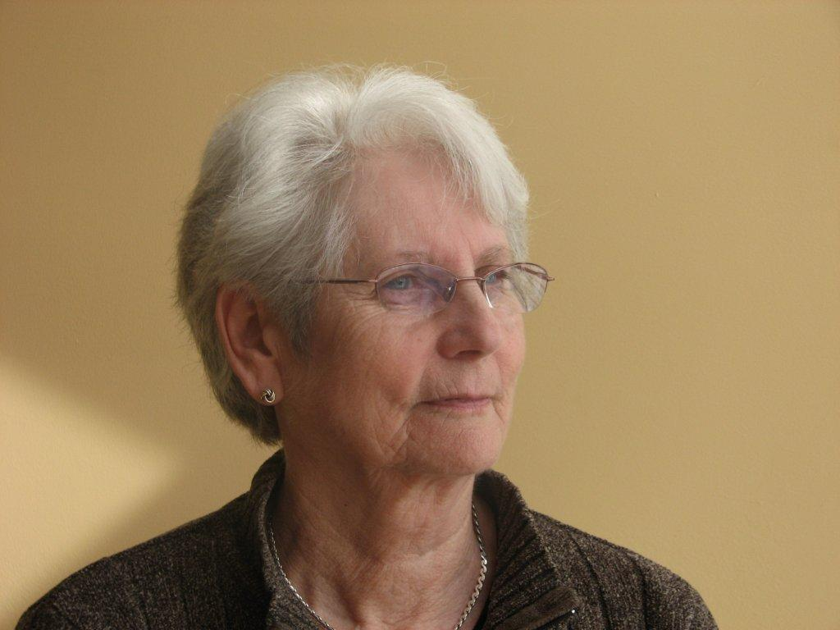  Stella Lord  Stella Lord has been a long-time advocate for women’s rights, social justice, progressive social policy and somewhat more recently for the environment. These concerns have been central to her choices for education, and for paid and unpaid work. She has had a varied career and has worked as a legal secretary, a legislative assistant, a community-based researcher, an adjunct university professor and as a senior researcher and policy analyst for the Nova Scotia Advisory Council on the Status of Women.  Stella has also volunteered in various capacities with community, feminist, and social development organizations at national and local levels. As a member of the Board of the Canadian Research Institute for Advancement of Women (CRIAW) during the 1980s and 1990s, she participated in national initiatives related to women’s equality and designed or coordinated several provincial and local community-based action research projects in Nova Scotia. She has also served on the boards of the Canadian Council on Social Development, the YWCA Halifax, and for two years as President of the Canadian Federation of University Women-Halifax.  Following her retirement from paid employment in 2004, Stella completed a PhD in Sociology from Carleton University. Her thesis on gender and the restructuring of the Nova Scotia income assistance system prompted her to become more actively engaged during her post-retirement years in advocating for welfare reform and the development of a comprehensive provincial poverty reduction strategy. | In 2012, she became a founding member and then Co-Chair and voluntary Coordinator for the Community Society to End Poverty-Nova Scotia (CSEP-NS), an organization advocating for poverty reduction and welfare reform. Representing CSEP, Stella sat on the Halifax Partnership Homelessness Working Group for three years and was involved in the United Way-Halifax poverty reduction initiative.  As a research associate with the Nova Scotia chapter of the Canadian Centre for Policy Alternatives, she helped to edit the Report on Child Poverty in Nova Scotia for several years and since 2013, she has been a member of the Campaign-2000 Steering Committee, a national advocacy organization on issues related to ending child and family poverty.  More recently, Stella has worked to link poverty and other vulnerabilities with emerging issues associated with climate change. Her interest in this began after hearing Elizabeth May speak to a women’s group about the 2009 Copenhagen conference. Under the auspices of the Canadian Federation of University Women (CFUW-Halifax) Stella took the lead in organizing an inter-generational mini-conference on Women and Climate Change for International Women’s Week in 2012 and a research group that developed a resolution to promote action on climate change that was passed at the CFUW AGM in 2012. In 2018, alongside women from G-7 and other countries, she participated in W-7, a federally funded forum sponsored jointly by Oxfam and Climate Action, designed to provide feminist perspectives on key areas of concern to the federal government in preparation for the G-7, including climate change. Stella continues her interest in action on environmental and climate change issues as a member of the Ecology Action Centre and the Anglican Diocesan Environment Network. Along with her husband Bill, daughter Kate, and grandson Luc, she is a member of St. Paul’s Anglican Church in the Grand Parade, Halifax.

Urgent Bold Climate Action NOW
Sign a petition asking the federal government to support a strengthened 2030 emissions target of 60 per cent reduction from 2005 levels to align with limiting global heating to 1.5 C and encourage implementation of an ambitious, achievable, science-based climate plan that advances intergenerational justice for Indigenous Peoples, workers and communities.
https://davidsuzuki.org/action/urgent-bold-ambitious-climate-action-now/
Halt Logging Old Growth Ecosystems Sign a petition to Parliament brought forward by MP Paul Manly from BC asking the federal govt.to 1) Work with the provinces and First Nations to immediately halt logging of endangered old-growth ecosystems; 2) Fund the long-term protection of old-growth ecosystems as a priority for Canada’s climate action plan and reconciliation with Indigenous Peoples; 3) Support value-added forestry initiatives in partnership with First Nations to ensure Canada’s forestry industry is sustainable, and based on the harvesting of second and third growth forests; 4) Ban the export of raw logs and maximize resource use for local jobs; and 5) Ban the use of whole trees for wood pellet biofuel production.
https://petitions.ourcommons.ca/en/Petition/Details?Petition=e-3408
Tell big polluters to pay up - Greenpeace Canada
This petition is asking you to add your name to support your local government in holding big polluters accountable for their fair share of the costs of dealing with climate change.
petition: The last 10 vaquita porpoises could die, if the government of Mexico doesn't act fast (thepetitionsite.com) Vaquitas are the rarest marine mammals. They are cousins of the dolphins and there are only 10 left! This is due to them drowning in a type of illegal fishing net being used. This petition is asking the government of Mexico not to loosen the rules that protect these amazing creatures, but to enforce them so the vaquita can be protected.
petition: 5,000 Baby Flamingos Died Because Humans Took Their Water! (thepetitionsite.com)
This petition is asking for your help to protect a breeding ground for flamingos in Turkey. The water of their lake is being diverted for human use and nothing is being left for the flamingos. Sign the petition to urge the government to protect its flamingos and to not do the same thing again.
petition: Europe plans to be the first carbon-neutral continent. Urge North America to follow suit! (thepetitionsite.com)
Europe is setting itself to become "the world's first climate-neutral continent by 2050". North America must become a carbon-neutral continent too, and this petition is urging the Canadian, American, and Mexican governments to act.
Drought – Lake Oroville Orville has been a name I was used to. I had a school chum called Orville and later in life I had a buddy by that name. That Orville and I were always bragging about our chickens. When I had seventeen varieties of fancies like Feather Footed or Polish Top Hats or Banties or Barred Plymouth Rocks; Orville was always getting a new variety I didn’t have.
This week I heard of another Orville, sounds the same but spelt Oroville, as in Lake Oroville, California.
It’s a sad story
Most have heard of the California forest fires which were burning twenty years before the British Columbia fires became a norm each year.
Their fires have slowed down, but the land faces another problem, drought.
I have heard the word “drought” and thought I knew what it meant. Things dried up and plants not growing well. It doesn’t rain much. What water is available disappears quickly in hot weather. Crops maybe half the size and yielding little. People in far off lands having little food because of drought.
Taken from California Dept. of Water Resources below is Lake Oroville in May 2020
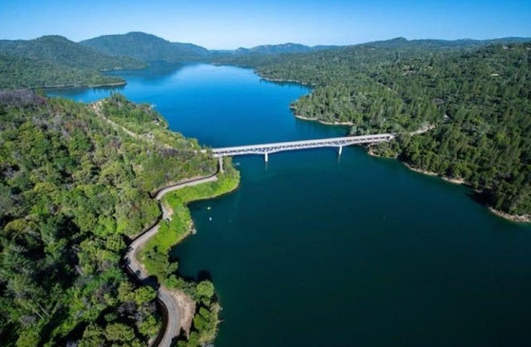
and then in July 2021.
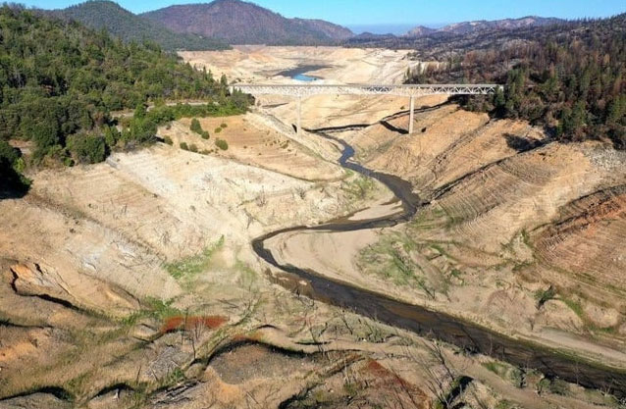

It is hard to complain about a week of rain now, isn’t it?
By the way just out of view of the first photo is a yacht club with boats anchored every so many feet apart. Or they use to be there.
Pretend you had a science project and wanted to talk about how climate change is affecting water reservoirs. Better to pick a Canadian example but you could use the following as your method.
Lake Oroville is a reservoir made by redirecting the Feather River. (Where is Feather River? Is that being affected?)
The Feather River is 76 miles long and is the main tributary (or branch) of the Sacramento River. Does it have less water this year? (Research says drought is affecting parts of that river.)
The Sacramento River starts in Lake Siskiyou. Are water levels affected there? It appears not.
So, the drought is taking place between Lake Siskiyou and Lake Oroville, at least part way down the Feather River.
What uses a lot of water? Usually, it is agriculture. Is there a lot of farming along that route? What else could affect water use? Have towns grown in population? Has an industry that uses a lot of water moved into the area? How has the weather been there?
So why would we care about that? Stay with me here
All of this takes place NINE, repeat 9, hours drive away from the British Columbia border. What do the rivers and reservoirs in British Columbia look like? Can you find pictures from last year and now?
This is the stuff that not only makes great science projects but makes you an expert in your school on water systems and climate crisis. Print this out and tuck it away until Mr. or Mrs. Science Teacher says to think up something for the science fair.
Water Fun – Water Balloons I found a few videos of how to play a game with water balloons.
https://www.youtube.com/watch?v=roqgB6XZdmQ
https://www.youtube.com/watch?v=LgLVndcqrYs
https://www.youtube.com/watch?v=Vndl2OW-oKk
IMPORTANT NOTE: When your game is finished make sure you throw the balloons and any pieces in the garbage. Balloons are a real hazard to wildlife and waterways.
Then I went looking for a craft that has to do with water, I love the homemade sprinkler idea. I don’t have my own to show you, so the webpage is quoted. When I made mine, I used a soldering pen to make the holes in the plastic bottle. I used duct tape to attach the hose to the pop bottle. I tried a plumbers tape another time and a friend found proper attachments at the hardware store to clamp the hose to the bottle. Either way it is a lot of fun on a summer’s day. If possible, hang this on a tree. Gardeners, get those hooks to hang plants on and hang this in your garden for irrigation.
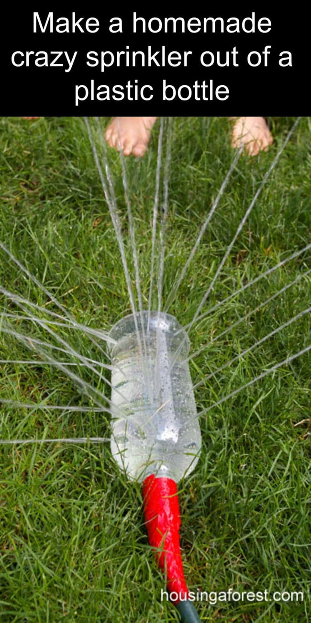

Something to Eat
Grandma likes to make big recipes. I make them and freeze them as I know every week, I need at least one night of “warming something up”. I like to make them in these loaf pans. They are just enough for Nana and I, with maybe a salad on the side. There are always one or two people in the community that could use a night off cooking. (Like my neighbour with six new Boston Terrier puppies at her house) Remember your service work. My rule usually is Make 4; use one, give one, freeze two. You will be surprised how useful these are.
Cheesy Sausage Potatoes Casserole
Sausage meat, can be bought loose or remove casings from a pack of sausages
Potatoes Half of a bag of hash browns or boil up half a dozen potatoes, cool and cube.
An onion chopped up
A tin of cream of mushroom soup (always need cream of mushroom soup)
Veggies: Leftovers or in this case I used a tin of mushrooms and a can of carrots
Shredded cheese, amount according to your preference.
Cook sausage. Add everything else to a big bowl and throw in a handful of cheese. Here is where I check the cheese box for any possibly aging too well cheese. Add cooked and drained sausage. Mix well and put in baking dishes. Top with more cheese. Cook about half an hour to 40 minutes according to the size of your dishes. (Bigger pans need more time to heat to the middle) Enjoy!
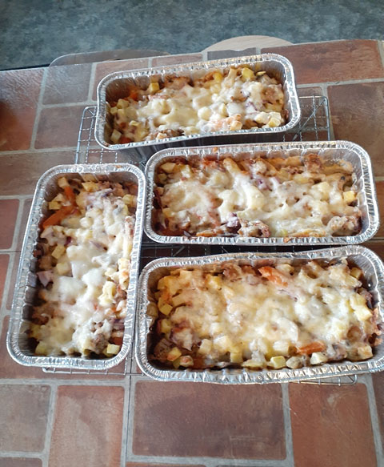
Grandma is part of a group called Random Acts of Green out of Peterborough, Ontario. They have a Facebook page that shows off any Acts of Green they can find. Check them out sometime.
Grandma would love to hear of any ideas for crafts or food or just a green story from around your home. For instance, there is a gentleman down the road who plants flowers in an old BBQ that he puts out by his mailbox. A great way to re-purpose. Send any ideas to caz@grandmasgoinggreen.com

All things look to you, O Lord,
To give them their food in due season;
Look in mercy on your people,
and hear our prayer for those whose lives and possessions
are threatened or destroyed by drought, flood and fire.
In your mercy restore your creation and heal our land.
So guide and bless your people,
That we may enjoy the fruits of the earth
And give you thanks with grateful hearts,
Through our Lord Jesus Christ. Amen
https://anglicanfocus.org.au/2019/09/23/prayer-for-rain-and-those-affected-by-the-ongoing-drought/

