July 27, 2021
Email: endionspei@gmail.com Website: nspeidiocese.ca/den
Facebook: Environment Network Diocese of NS & PEI
Welcome to our weekly Enews. The Diocesan Environment Network (DEN) of the Anglican Diocese of NS & PEI, was formed in response to the Fifth Mark of Mission and the latest addition to our Baptismal Covenant which has become our Mission Statement.
“To strive to safeguard the integrity of creation and sustain and renew the life of the earth.”
To do this we educate and encourage stewardship through social media and liturgies, connect with other environment groups, pray together, celebrate art with each other and grieve together.


Christians around the world are invited to give particular attention to praying for and caring for God’s Creation as part of the global Season of Creation observed from September 1 to October 4 every year. The theme this year is “A Home for All”. For more information, check out the DEN webpage: https://www.nspeidiocese.ca/pages/den-season-of-creation--288
Or email endionspei@gmail.com


Praying with the DEN Community The last Morning Prayer for the summer will be next Friday August 6th at a new time 8:30 by Zoom. To obtain the link, please email endionspei@gmail.com

Say Yes! to Kids
Not all contributions have yet been received, but our diocesan fundraising team, Environment Network Diocese of NS & PEI, will surpass its $5,000 goal for Say Yes! to Kids. Yeah! The Say Yes! to Kids Campaign of the Anglican Foundation of Canada (AFC) thanks all those in our diocese who have contributed. Many, many thanks. The overall goal of $100,000 for Say Yes! to Kids is now in excess of $110,000!! Fantastic! Missed contributing? Not to worry. It is easy to donate to AFC’s Kids Helping Kids by placing that title in the memo line of your cheque payable to the Anglican Foundation, addressed to the Anglican Foundation of Canada, 80 Hayden Street, Toronto, ON M4Y 3G2. Or donate on-line. It is easy-peasy: https://www.anglicanfoundation.org/kids/
Interested in having your parish possibly benefit from the funds raised. Go on the Anglican Foundation website – www.anglicanfoundation.org to see the comprehensive Request-For-Proposal package. Under the heading Apply – click on 2021 Request-For-Proposal. Contact us here if you are interested in preparing a proposal. The Diocese has a team that reviews AFC grant proposals to help ensure they check all the boxes and are definitely interested in having our Diocese benefit from Say Yes! to Kids funds. DEN will put you in touch with the right people.
Canada is on Fire – This site shows an interactive map for events happening on July29th, a National Day of Action. Towards the bottom is the petition calling on the government to respond to this crisis with emergency-level climate action. https://350.org/on-fire/

Did you know? General Synod of the Anglican Church of Canada in 2019 resolved to encourage the curtailment of single-use products with the intention of ending their use by 2023 within parishes and to encourage individual Anglicans to reduce their reliance on plastic products. https://gs2019.anglican.ca/cc/resolutions/a201/

Sustainable Food Packaging. This petition calls on Loblaw Companies Inc to provide sustainable packaging. https://www.thepetitionsite.com/takeaction/558/752/332/

Did you know that 99% of plastics come from fossil fuels and contribute to climate change? Or that only 9% of plastic waste is recycled in Canada — and that the other 91% mostly ends up in landfills or in the environment? Worst of all: did you know that big companies like Coca-Cola, Pepsi and Nestlé know this and still choose to produce more plastic waste? It’s time for them to abandon single-use plastics and invest in reusable and refillable packaging now. Despite their promise to act on plastic pollution, these three food industry giants are still working hand in hand with the oil industry to maintain their production of billions of disposable plastic packaging. To sign a petition, click on this link.
Champions of Plastic Pollution

July 27th, TODAY, is a National Day of Action for Greenpeace. To read more:
https://www.greenpeace.org/usa/

Palm Oil "Kids as young as ten are forced to work grueling 12-hour shifts to harvest palm oil in Indonesia and Malaysia. Exhaustion, injuries, heavy loads, and worst of all: rape and trafficking. To add insult to injury, huge swathes of magnificent rainforest are destroyed to make way for these awful palm oil plantations. And Ferrero is happily buying this palm oil to make chocolate spread, cookies, and candies." To sign please click on the link below.

https://actions.sumofus.org/a/ferrero-palm-oil?sp_ref=724993779.99.219096.f.672534.2&referring_akid=92336.12756693.qErBcd&referring_source=fwd&source=fb

This week we are happy to introduce you to Claudia Zinck. Claudia aka Grandma has been a regular contributor to the Enews in her “Grandma’s Going Green” feature. It is hoped you are having fun sharing these articles with your children and grandchildren and teaching them about taking care of our resources. Please share your photos of your fun on our Facebook page. | 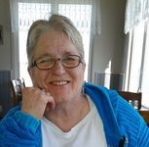

Born in Halifax, I was raised the first 12 years on a purebred Shorthorn cattle farm in East River, NS. My Dad was a herdsman at the major exhibitions across Canada where he earned Grand Champion Ribbons with the herd belonging to Cyrus Eaton. Mom and Dad were only regular country folk. I grew up tending gardens, picking berries, and canning shelves of food when not doing craft work. Around here my craftwork ability was summed up simply by calling me Ruby’s daughter. My mother liked to learn every craft known to humankind and I followed in her footsteps.
As my children grew, I was the Girl Guide leader, the Sunday School teacher, and the Junior Oddfellow leader. Working with children was always part of daily life.
I always had a desire to go back to school. Back in the 60s, when in High school the first time, grade 11 was considered “good enough for a girl”. Hear it and never believe it. I never did. When I became a single mother, I kept looking for grants to send me back to school yet put food on the table. One day an academic advisor called to give me more disappointing news and chuckled as she said, “It’s sort of too bad you weren’t disabled, I have tons of programs I could get you into”. I asked her what was considered “disabled”. As she started listing off medical problems, I kept thinking I am that and that and that. You see another part of being Ruby’s daughter was never allowing yourself to be considered different. My dislike of sports probably relates to all the practises at home. Practise so I could be considered just poor at sports, not a person with disabilities that could not play sports.
Going back to school in the nineties was a wonderful experience. My children may disagree with me. I needed my academic grade 12 to continue to university. That meant going back to High School. My eldest son refused to go to PROM unless I was NOT there. That certainly did not bother me. My daughter, who planed on Biology at the time decided she would NEVER do a class I did. I taped all my university classes and played the tapes while peeling potatoes or washing dishes. My years at St. Mary’s earning an Anthropology Degree minoring in Native Studies was an education, not just working to get good marks. The year I graduated from university, my eldest was out on his own, my daughter was headed to university and my youngest was starting high school. Yes, it was a struggle at times, but the benefits outweighed anything else.
Rev. Laura McCue became our Parish priest and talked me into coming back to church. Rev. Marian Lucas Jeffries arrived and started Messy Church. Somehow, I become the one in the village to help with children’s events. The circle continues as I write the column for the DEN newsletter.
I presently work in a call centre environment for an office supply company. For the past 17 years I simply go to work in my daughter’s old bedroom, hooked up to America as a work from home, customer service clerk. Being a W@H has allowed me time to do so many things while earning a living.
Presently I am the warden for St. Barnabas in Blandford, the Environment rep for the Parish of Blandford and enjoy writing the weekly column in DEN and freelance for several papers.
When thinking of how so many of our churches have few or no children’s programs, having a grandma figure that TRIES to write so even an eight-year-old can understand, may be what is needed. I hope my weekly chats may expand a bit of knowledge on the environment and give Moms, Dads and Grandparents ideas for conversations and activities to do. My dream is a Youth newsletter for kids from any denomination to just have a place of prayer and activities. You just never know what may be in our future.
Claudia Zinck
Ruby’s daughter, Anthropologist, Environmentalist; AKA Grandma

Green Story - Why be concerned about reducing?
Paper is one of the most used substances we have. It takes trees to make paper, although there have been other plants used for test products. Trees give us at the most basic level, oxygen to breathe. Anytime we can REUSE, REPURPOSE, or even RECYCLE paper, we are helping the planet.
No matter what else is done, always think how to REDUCE, just a little.
Reducing does NOT mean DOING WITHOUT. It can mean using what you have. Here is an example. Today we are doing a paper mache craft. One ingredient you can use is shredded paper materials like bills or newspapers. Most of the time I put my shredded materials in a clear bag to go to our waste facility. If I can use some for a craft, all the better. I reduced what was carried away in a gasoline burning truck.
This way, I am the one REUSING, REPURPOSING, instead of the big machines at our landfills. I am REDUCING what goes out to the curb. I am using what I have at home without any added purchase.
A few cups of shredded paper are NOT going to make a big difference in Nova Scotia or PEI’s landfills. So why even bother?
We are not alone on this planet. We will not be the only ones doing this.
Let us pretend.
Not knowing how many people get this newsletter let us pretend just 100 people receive it. Out of that hundred people, let us pretend that 10% or 10 people decide to do the paper mache or paper clay craft.
It is a fun thing to do so those 10 people decide to get maybe 2-3 kids each to work with them. So, maybe 30 people making the craft.
We have already changed my 2 cups of shredded bills into 60 cups of shredded paper. That is a decent size pile of recycled paper used.
Now pretend this story got into another paper I write for that has a readership of 31,000
Using the same numbers, 10% of people doing the craft (That is more than I would expect but we are pretending here) makes 3100
Each one shreds or tears up 2 cups of paper 6200 cups and if just 2 (not 3) people did the craft it makes 12400 cups
Sounds like a lot but what does it look like? That is about 733 milk cartons full.
Grandma works in inches, but we can convert to meters later. Each milk carton is a bit less than 4-inch square. So, if we just measured the bottom of milk jugs and lined them up, what would that look like? So 733 x 4 equals 2932 inches, 244 feet, 74 meters LONG.
More than the wingspan of a 747 jet
¾ of the size of a football field
Seven school buses lined up nose to bumper
4/5 the size of Big Ben clock tower in London or the Statue of Liberty in New York. They are both the same height.
Sounds like a big number to me. All of that because I suggested to play with paper mache.
What if I make a bigger recipe, used more shredded paper?
Remember I just used the size of the bottom of the milk carton for these measurements. That shredded paper has width and length AND height. Anyone learn about l x w x h in Math class?
So, the amount of paper mache I used is much bigger? If the milk cartons were all squashed flat, I probably have filled in that imaginary football field width and length.
That is a lot of REDUCING. In this pretend idea, what caused all this reducing? It was by telling you about shredding paper and making paper mache bowls.
It is called the POWER OF ONE. One person does one thing that encourages others to do the same. They encourage still more people and so on.
Go tell someone!
For our younger members of congregations, I found cartoons about the environment you may like.
Video Book, Max, the Little Monster Saves the Earth
https://www.youtube.com/watch?v=2Mkwhe6LOBo
A Whale’s Tale
https://www.youtube.com/watch?v=xFPoIU5iiYQ
Recycling Video for little ones
https://www.youtube.com/watch?v=BaFpv03hq-4
For those a little older to 110 this is one of my favorite videos
The Story of Stuff
https://www.youtube.com/watch?v=1YQ6eUqcEh8

Making Bowls
This week we are making bowls. There are two methods we are using today, and they are called paper mache and paper clay
Paper Mache
Mix up a bowl of flour and water, making it very watery. Start with half a cup of flour and add water. Make sure all lumps are out of it (By the way, this is half of how you make gravy)
Tear up pieces of newspaper or grocery flyers., ads, or junk mail. Newspaper is the easiest here.
Ask your parent for a bowl to use. Cover the outside of the bowl with plastic wrap or aluminum foil. Turn it upside down so the bottom and sides are toward you.
Have your flour and water in a wide container.
Run a piece of paper over the flour and water mix, getting it wet before laying it over the bowl.
Keep wetting the paper and adding it to your bowl form till you feel you have enough layers to make a strong bowl. Using a pastry brush or a paint brush give the whole outside one last coat of the flour and water.
Put it somewhere to dry for days to a week
Then paint it. These make great gifts. I often thought it would make a great collection bowl to be used at a special service.
Paper clay
Shredded or paper torn into small pieces are great to use. Half a roll of toilet tissue is great to add to it.
One sculptor I heard of uses all toilet tissue for a softer finish. In the pictures Grandma is using both.
Put shredded paper in a bowl and cover with hot water. Leave it to soak an hour or more. Toilet tissue needs no soaking time.
Loosely I use a 3 to 1 ratio: 3 cups paper pulp and 1 cup flour
Some people put this mixture in a mixing bowl and beat it with a mixer to make it smoother.
To make it more clay than mache I add some white glue. If you have any left-over plaster or crack fill add it to the mixture.
Again, we get bowls, turn them upside down and cover them with plastic wrap. By handfuls, smooth the paper clay around the bowl
Set it aside to dry and then paint
There are so many videos on making paper mache or clay on the internet. Remember to click VIDEO at the top of a Google search to get a list of videos on any subject. I always understand better with pictures.
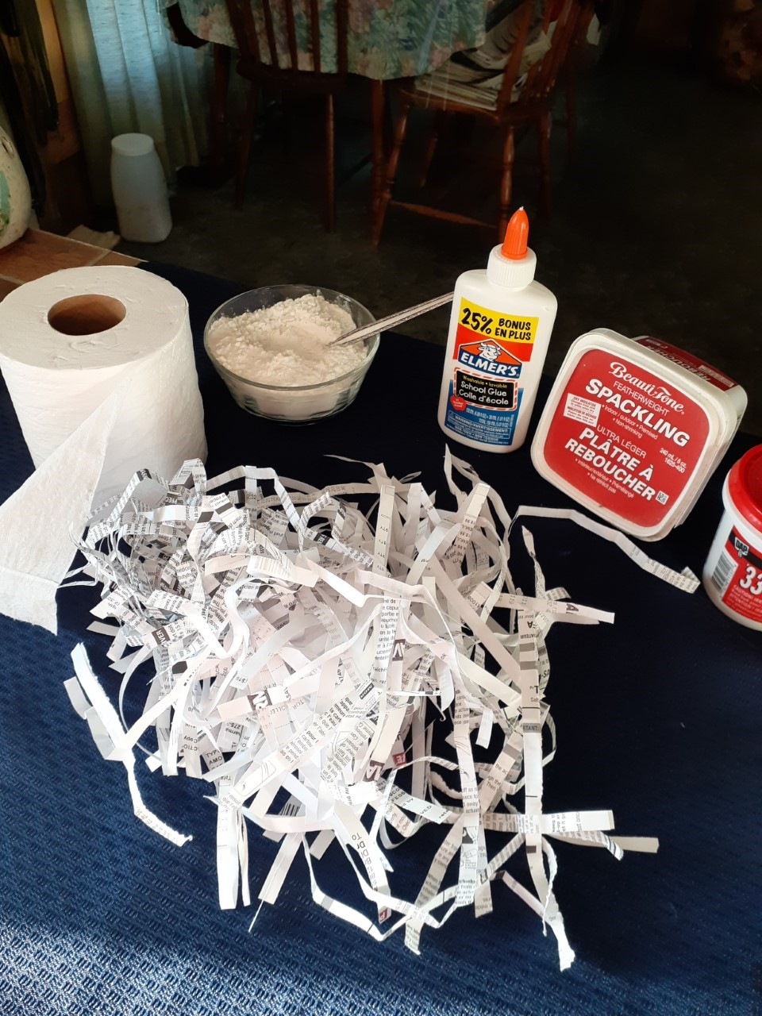 | 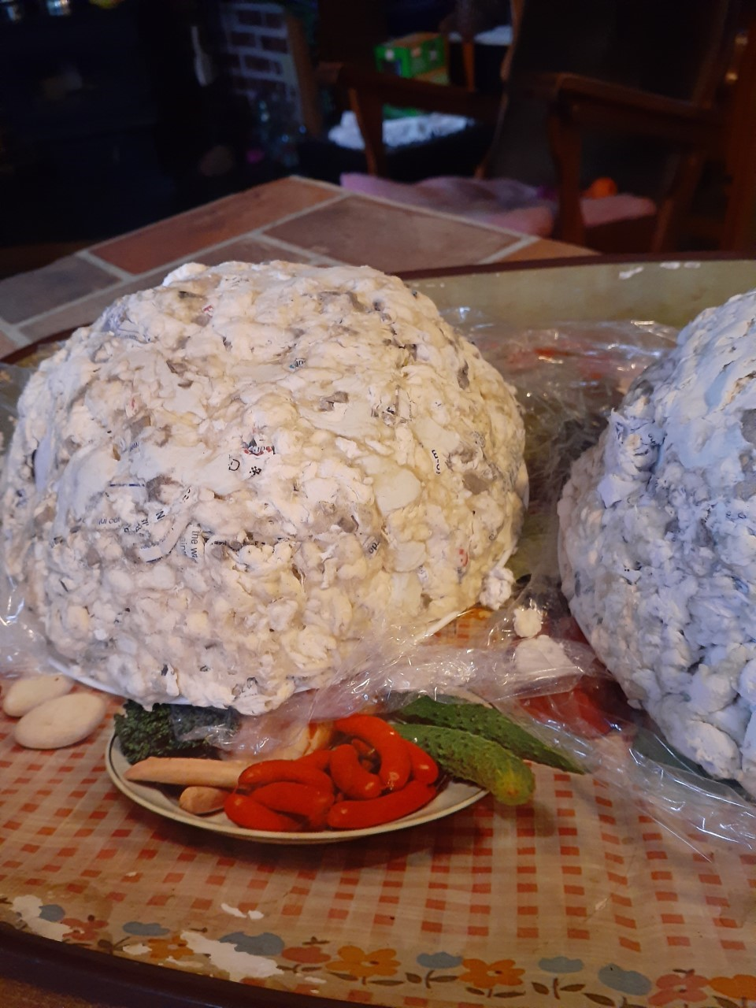  Grandma will send a picture when her bowl is dry and painted

Something to Eat – Fruit Popsicles
So easy.
Puree fruit. Any combination. One of our favorites is strawberry and kiwi
Banana and avocado
Blueberry and peaches
The puree could be put over ice cream or eaten just as it is right away OR
Put it in homemade popsicle sticks and freeze overnight
Really good for teething babies. (a bit messy but fun for them)

Voice to the Seed:
I hold you in my hands and hold you as my future.
As you grow so will my vision for a hunger-free world.
By your growth you will help us celebrate life.
Thanks for reminding me that I, too, am a sacred seed planted in God’s garden.
Voice about the Seed:
You look for a resting place
A place of silence, in the bosom of the earth.
Your patience makes you great
The womb of the earth nourishes you,
Your power is the source of life on earth.
May your willingness to die make us humble;
May your rising again to the sun give us hope.
Voice of the Seed:
I am a Seed
I need good soil to grow
I need the sun to glow
Water to refresh and replenish me,
Air for my leaves to breathe
Space for my roots to spread
Now, now I can be all that the Creator hopes for me.
Amen.
https://pwrdf.org/year-one-focus-climate-change-and-food-security/

