June 29, 2021
Email: endionspei@gmail.com Website: nspeidiocese.ca/den
Facebook: Environment Network Diocese of NS & PEI
Welcome to our weekly Enews. The Diocesan Environment Network (DEN) of the Anglican Diocese of NS & PEI, was formed in response to the Fifth Mark of Mission and the latest addition to our Baptismal Covenant which has become our Mission Statement.
“To strive to safeguard the integrity of creation and sustain and renew the life of the earth.”
To do this we educate and encourage stewardship through social media and liturgies, connect with other environment groups, pray together, celebrate art with each other and grieve together.
Christians around the world are invited to give particular attention to praying and caring for God’s creation as part of the global Season of Creation, observed from September 1 to October 4 every year. The theme this year is “A Home for All”. Very pertinent given recent events. Let us know if you would like a guest preacher or speaker during Season of Creation and please share with DEN the innovative ways your parish will be celebrating God’s creation this September. For more information check out the DEN webpage for Season of Creation at https://www.nspeidiocese.ca/pages/den-season-of-creation--288 or Email endionspei@gmail.com
Soap Making Pop-Up Monday July 5th Rev. Tammy Hodge Provec will be offering a Soap Making Webinar via Zoom. If you are interested, please email endionspei@gmail.com for the link.
Praying with the DEN Community Morning Prayer will be on the first Friday of the month for the summer. Join us on June 4th, July 2nd and August 6th at 9:30 by Zoom. To obtain the link, please email endionspei@gmail.com
Dialogues at Thinker’s Lodge - a 4 part webinar series on Climate-Induced Societal and Ecological Breakthrough in Atlantic Canada. June 16th is the first one on Governing for Ecological Citizenship. For more information and to register, https://ecologyaction.ca/sites/default/files/images-documents/SDGA%20Action%20Toolkit%20EAC%20V3.pdf
The next session is June 30th – TOMORROW. To sign up:
https://www.eventbrite.ca/e/dialogues-at-thinkers-lodge-tickets-158644992443?fbclid=IwAR27jCfTXA4oS7AeaWY5uhnSJvA3aTOq5EaxHjpaQU7-9L5xxkQgSO1ZBpQ
Two more sessions follow this on July 14th and 28th.
The Ecology Action Centre as part of their Urban Development Advocacy, is focusing on increasing public engagement with the HRM Regional Plan Review Process. Here’s how you can have your say up until July 16th.
1. Learn about the EAC’s top priorities for the Regional Plan and then let decision makers know what your priorities are for the Regional Plan Review: Take the Halifax’s Shape Your City survey.
2. Stay in the loop by signing up for the EAC’s Regional Plan email list.
3. Share the facts with your community by sending friends a link to this page.
And Check out this webpage put together by the EAC's Urban Development Advocacy Team to learn more about the regional plan review and how to engage: https://ecologyaction.ca/have-your-say-future-hrm-halifax-regional-plan
We would like to introduce you to one of our painters in the gallery, Luke Haugen-Strand

Luke was born in Sherwood Park, Alberta and spent his early years in Chilliwack, BC, Duluth, Minnesota, Ottawa, Ontario and Thunder Bay, Ontario. He moved to Sackville, NB at the age of 11 and just recently relocated to Halifax. He enjoys the cultural opportunities in the Maritimes and the closeness to nature.  Luke has been involved in tha arts all his life, beginning with theatre and writing, having won 2nd Place in the Sheree Fitch Prize for the Writer’s Federation of NB. At 20, Luke found his real passion in painting and specializes in portraits, landscapes and still lifes. He has taken private lessons in sculpture, drawing and painting and has participated in restoration work on mezzo relief panels in Hamilton ON and centennial monuments in Dunnville ON. Most recently, Luke was Artist in Residence for Kairos where he created a series on ecological justice.  Luke has been commissioned to do many paintings including:  - Three large paintings for the Ecp play “Bearing Witness” by Elizabeth BGlenn-Copeland  - An Advent series for Sackville United Church  - A Buckminster Fuller inspired piece for Quantam Healing workshops held inCanada and France. |   Enjoy Luke’s work on his website: https://www.lukehaugenstrand.com/
https://www.nspeidiocese.ca/ministries/diocesan-environment-network/pages/den-hope-inspiration-art-gallery Contact us by email endionspei@gmail.com

The International Energy Agency says we must stop all new fossil fuel projects this year to avoid the worst effects of climate change. Instead, Nova Scotia is looking to expand offshore exploration and drilling by oil and gas companies. This petition will be added with the Ecology Action Centre’s formal comment on July 5th. We have a chance to add our voice and have a say in what happens in our Atlantic waters.

Sign the petition to stop offshore oil and gas expansion in Mi'kma'ki/Nova Scotia! | Ecology Action Centre

Canada is a country with undeniable natural beauty and diversity, and it comes with a responsibility to protect and care for it. Less than 15% of our oceans are currently protected and many industrial practices threaten marine life. Canadian Parks and Wilderness Society has created this petition to call on Canada to protect at least 30% by 2030, along with 4 other guidelines that will lead to the protection and conservation of our oceans.

petition: Call on Canada to champion strong marine protection! (thepetitionsite.com)

The Canadian Environmental Protection Act is a cornerstone in environmental law and keeps Canadian safe from toxins. However, it hasn't been updated in 21 years! Bill C-28 has vital reforms in it to match our current times and needs, including our right to a healthy environment. This petition will be sent to the Minister of Environment and Climate Change and to opposition environment critics, asking them to make strengthening and passing Bill C-28 a political priority.

petition: Canada Must Pass Legal Protections Against Toxic Air Pollution! (thepetitionsite.com)

A mining project in India is going to destroy 382 hectares of forest. They are doing this to collect diamonds, but the forest is also a precious and priceless resource. This project also threatens the people in the nearby communities who are against it, including 5,000 tribal people who will likely be forcibly relocated from their traditional homes and land if this project goes ahead. There are millions of trees at risk and there are violations happening of people’s rights, we can stand with them by signing and sharing this petition.

Save 2.15 Lakh trees in buxwaha forest (jhatkaa.org)

The CAN-Rac Canada Executive Director/ Directeur général, directrice générale position is now open. The Job Posting can be found at this link:
https://climateactionnetwork.ca/job/executive-director-directeur-general-directrice-generale/
CLOSING DATE FOR APPLICATIONS: July 21, 2021 at 9pm ET START DATE: September 7, 2021 or as soon thereafter as possible.
From the Diocese of NS & PEI Office: Please forward this information to anyone interested in the position of Financial Comptroller for the Diocese. The job posting is on the Career Postings section of their website, which can be found at https://www.nspeidiocese.ca/about-us/pages/career-postings.
The Independent Expert Panel for the Legal Definition of Ecocide convened by our foundation has completed its deliberations. The proposed definition of ecocide as a 5th crime under the Rome Statute is now available for states to consider - and for civil society to demand. For more information: https://static1.squarespace.com/static/5ca2608ab914493c64ef1f6d/t/60d1e6e604fae2201d03407f/1624368879048/SE+Foundation+Commentary+and+core+text+rev+6.pdf

The Say Yes! to Kids Campaign of the Anglican Foundation of Canada (ACC) is wrapping up this week. The overall goal of $100,000 has been surpassed!! Bravo! Thanks to all those who have contributed to our fundraising team, Environment Network Diocese of NS & PEI. Haven’t contributed yet? It’s not too late. And, it’s easy peasy to donate on-line: https://www.canadahelps.org/en/charities/the-anglican-foundation-of-canada/p2p/say-yes-to-kids/team/environment-network/ Prefer to send a cheque? It’s payable to the Anglican Foundation, Say Yes! to Kids in the memo line, addressed to: Anglican Foundation of Canada, 80 Hayden Street, Toronto, ON M4Y 3G2. All contributions welcome! Help our team reach its goal of $5,000!
The online network is designed to proide support and resources for faith and spiritual communities. For more info and to sign up fo their newsletter, https://www.faithcommongood.org/faith_community_sign_up]

Editor’s Note: Hats off to Grandma aka Claudia Zinck for her themes each week and following through with something educational, then fun, then tasty. We hope you are sharing these .
Green Story - Cardboard
As a kid, I remember my mother saving every cardboard box she could get. She stored things in them. They were containers to carry just about anything. The grocery truck used a cardboard box to bring the groceries to the kitchen counter, unpacked and taken back to use with the next customer. Very seldom was a box destroyed. Old boxes on their last legs were used as a trash bin as a last resort.
Cardboard may have been invented back in China in the 1500’s but it was in England in 1817 when an accident while a printer was making paper seed envelopes that taught a process to fold heavy paper and make boxes. Kellogg was the first manufacturer to use thinner cardboard that we now call box board to package their cereal. The first packages had that wax paper on the outside of the box to improve its strength.
Ninety percent of products shipped in the world are packed in cardboard. Since the beginning of Covid, shipping has increased greatly. Luckily there were recycling programs for cardboard in place prior to this increase in box use.
Paper, box board, cardboard, catalogues, magazines and other paper-based products account for about half of the trash put out for pickup. Recycling this product alone saves large amounts of energy. Wikipedia tells us that 1 ton of recycled cardboard saves 46 gallons of oil, and only takes 75% of the energy used to make new cardboard.
Remember from last week that a cardboard box can be recycled and made into a new box at least 6 times.
If cardboard was a heat source, what is thrown away annually could heat 50 million houses for the next two DECADES. We need the people to invent ways to make that happen.
Trash is not just something we should just discard; it is a resource for a better life waiting to happen.
Here is some links to find more information.
Wikipedia, https://wiki.kidzsearch.com/wiki/Cardboard
http://www.oneearthrecycle.com/recycling-facts
https://www.cardboardbalers.org/cost-agricultural-solar-panels/
https://generated.com/cardboard-recycling-facts/
Spinners
Spinners can be made from many types of material. As a child my spinner had a large button to twirl. Today we will make a cardboard spinner.
You will need a piece of cardboard, markers and stickers to decorate, a pair of scissors and a piece of string.
Find something in the house that is a 4-to-6-inch circle. Use that to draw your circle on the cardboard. Cut out the circle.
Decorate the circle.
Find the center of the circle and using the pointy end of your scissor or a darning needle, punch two holes on either side of the middle.
Thread the string or twine through both holes
Holding the two ends in your hands flip the spinner around and around tightening your string.
Pull and release your string.
The string will twist back up the opposite way with each pull spinning the cardboard in the middle.
It is harder than it looks. It takes a bit of time to learn how to spin. Who is up to a challenge?
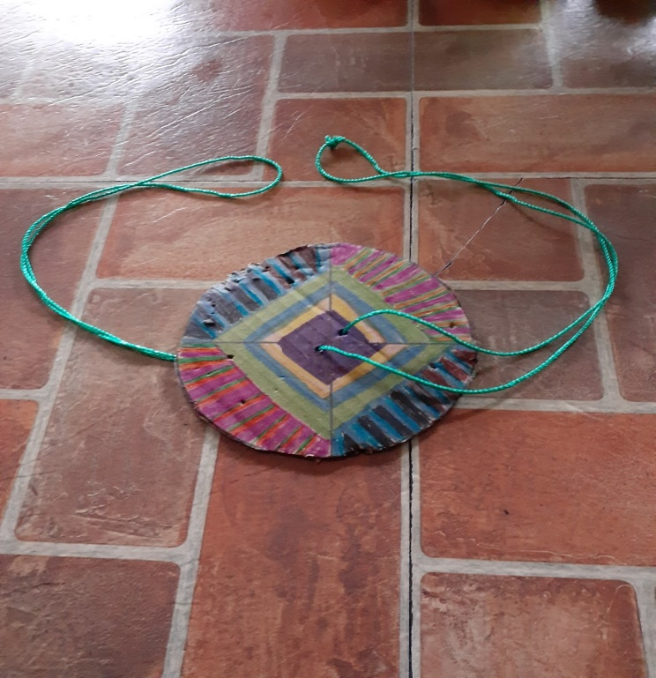 | 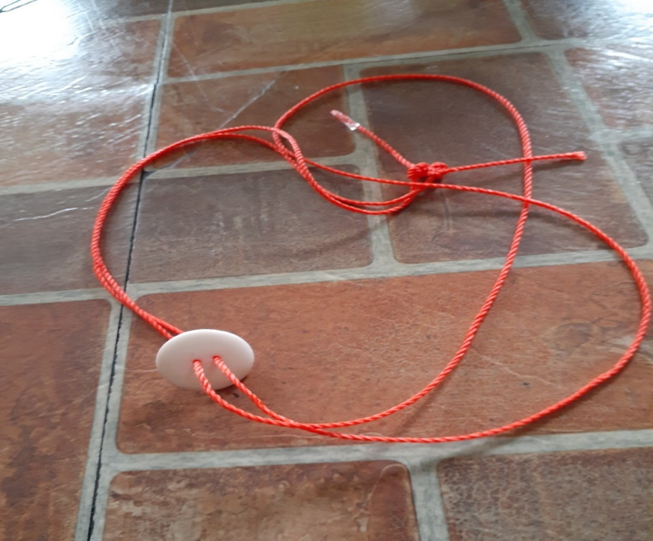

Something to eat.
Now if you want to keep with a cardboard theme, try making a Shoebox Cake at
https://www.youtube.com/watch?v=eauhsjFvfaE
Apparently in one part of Africa they bake a cake in a 24-bottle size beer box. It is easy for the kids to carry to school to share with their classmates.
Anyone has any other ideas of different cooking. I know I save tin cans to bake certain things in. For example, the tin that lobster meat came in made a mini cake for decorating when only 2 are sharing the cake. Enjoying a treat without the leftovers.
This chef makes his meatballs in an egg carton slowly baked in an oven to reduce fat.
https://seasonandthyme.com/meatballs-baked-in-egg-carton/
We will get into cardboard ovens later.
My attempt at food photography, my Fish Bake this week.
Fish Bake  Haddock, sole or any white fish (enough for a piece for each person there or more)  Half a dozen potatoes (give or take for the size of your family)  A tin of peas and carrots  Parmesan Cheese  Garlic  Onion  Breadcrumbs or a little flour  Milk, cream, sour cream, even cottage cheese for a bit of liquid  Peel the potatoes and par boil 10 minutes so still half hard.  Once cool, slice potatoes for a layer on the bottom of a baking dish  Add half an onion sliced and diced and 2-3 cloves of garlic.  Sprinkle Parmesan cheese over this  Lay your fish on top of this and if using cottage cheese add it now.  Breadcrumbs or a bit of flour goes next  Add the tin of drained peas and carrots.  Cut up the remaining potatoes, sprinkled with onion and garlic.  Add milk (with a bit of cream if you have it) to just come up from the bottom an inch.  Bake around 45 minutes according to the size of the dinner.  Now, if you have leftovers, next morning if you have extra time  Fry the leftovers in a pan and poach an egg to go on top of each serving.  “Some Good” | 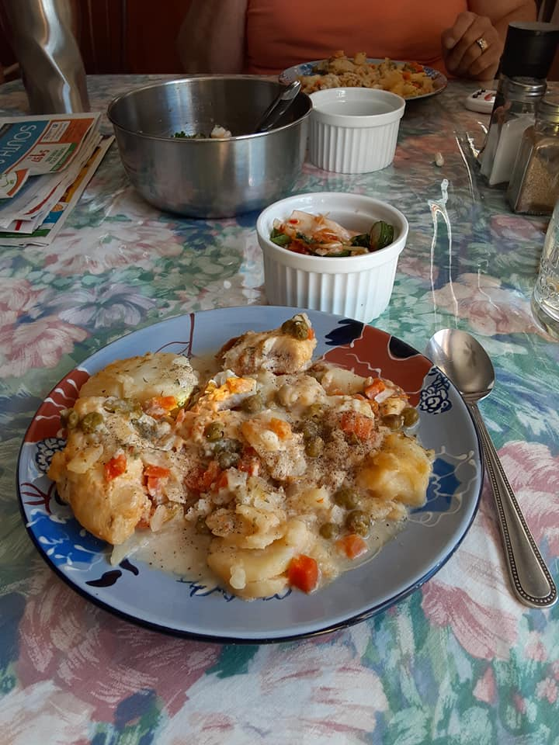

Grandma would love to hear from you at caz@grandmasgoinggreen.com. Till next week, Grandma is sending hugs.

A Prayer for the Nation
O God of many nations,
God of the nations of indigenous people
who nurtured and cherished this land for centuries
before it was taken away,
O God of the nations who generously shared their people
  - with us over the last 400 years,
O God of all our people: rich and poor, young and old, famous and unknown.
Pour out your spirit upon us and cleanse our nations of fear and hatred.
Fill us with compassion and peace and a thirst for justice.
Give our nation a new beginning in your Grace.
  - We pray in the name of the Holy Trinity, One God. Amen
The Very Rev. Dr. Peggy Patterson
https://gracecathedral.org/prayers-difficult-times/

